July 15, 2025

Applicability: Wolf Creek

Internal Release Information:
F2025-017
Created a new cover page type for Wolf Creek Single Column format. Cover page is not included in total page count and has the Revision and Use Category in a table on the page.

- [Check this box if a sql query or a data fix applies to this update].

Generic External Release:
N/A

Plant Specific Information for Release Letter:
Wolf Creek
Single Column Format
Added the “Cover Page – Not Included in Page Count” section type for use with the Core Work Instructions (CWIs) documents.

Testing Requirements:
Use Wolf Creek data
- Update formats
- Change the cover page type on an Administrative procedure (that has a Table of Contents) to the “Cover Page – Not Included in Page Count” section type
- Print the procedure
- Verify the cover page has a two rows two columns table containing the revision number and the Use Category.

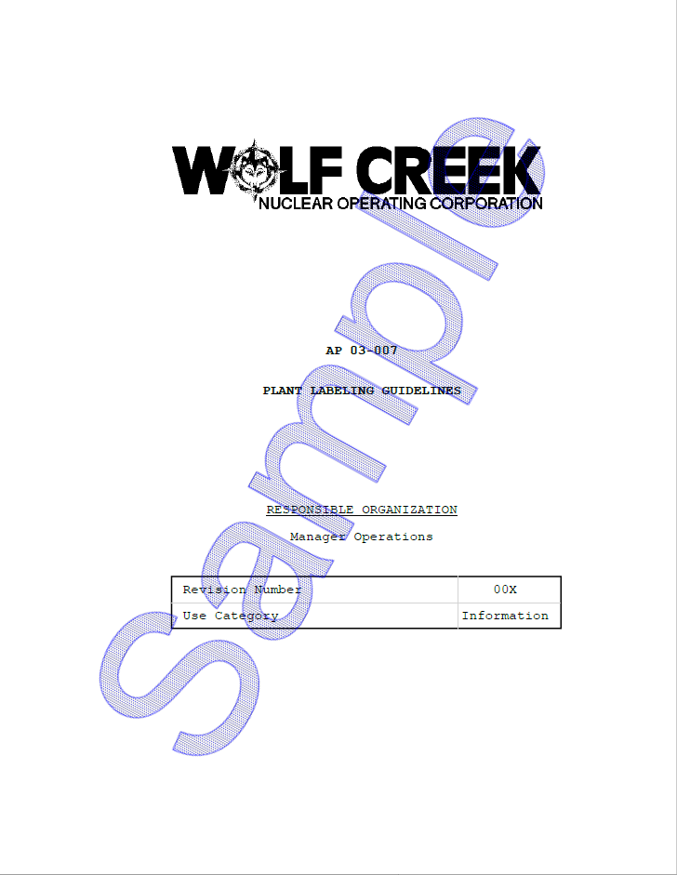

- Verify the cover page is not included in the total page count of the procedure and the page number of the first item in the Table of Contents is correct.

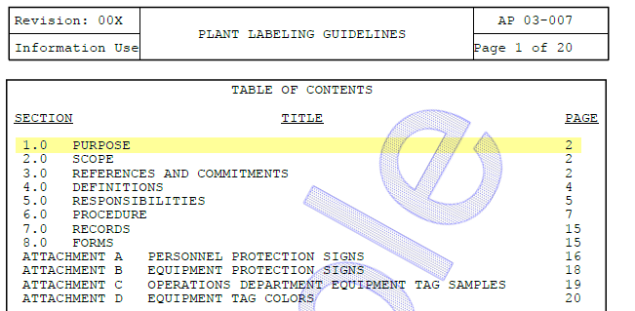

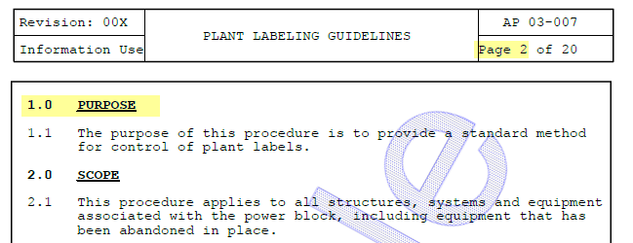

Changes/Additions to PROMS Manual and Training Videos:
[Do not use this section – for MRV/DMJ use]
- CSM submitted for PROMS User Manual: ____________.
- CSM submitted for training videos: ____________.

