October 28, 2024

Applicability: All Plants

Internal Release Information:
C2024-031 Option to Disable reopen closed tabs on PROMS reentry

When opening PROMS, prompt the user with a message box asking if they want to restore the tabs from their last session. Have a checkbox to remember answer if user does not wish to be prompted in the future.

Add an option to PROMS System Options so users can change whether to:
- Remember open tabs setting vs prompt at each PROMS opening
- Automatically re-open tabs vs always starting with no tabs open

- [Check this box if a sql query or a data fix applies to this update].

Generic External Release:
Added an enhancement to the recent PROMS feature that allowed PROMS to remember tabs left open when it was previously closed. New feature will allow users to disable this option (and start PROMS without tabs reopening) and to choose between PROMS always prompting users on re-entry if they want to open previous tabs vs Remembering the setting option the user previously chose and foregoing a prompt.

Plant Specific Information for Release Letter:
N/A

Testing Requirements:
- Use any plants database
- If no tabs were left open when PROMS was previously closed for that user, there should be no prompt regardless of setting
- Settings should be on a per user basis – i.e. one user should be able to have it set to Always remember vs Another have it set to Prompt each time.
- Prompt should perform appropriate option, with the checkbox saving information and foregoing future prompts.
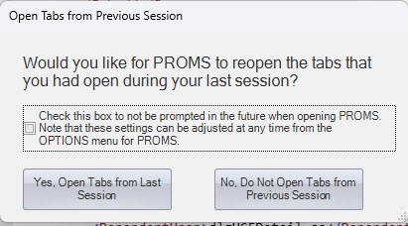
- These settings should also be able to be changed via Options
Note that “Auto Open” will only Show if “Remember Setting” is selected.
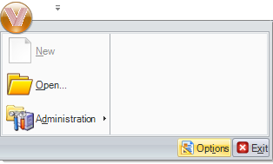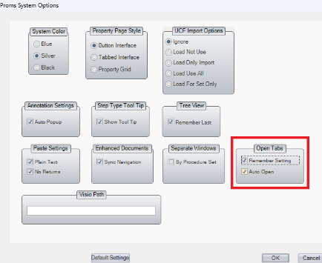

Changes/Additions to PROMS Manual and Training Videos:
[Do not use this section – for MRV/DMJ use]
- CSM submitted for PROMS User Manual: ____________.
- CSM submitted for training videos: ____________.

