C2017-033 Remove inserting “New Step” Text
Date: 4/18/2024

Applicability: N/A

Internal Data Fixes: N/A

Internal Release:
Removed the text “New Step” that is inserted when creating a new step from the V button.

External Release:

Plant Specific Information for Release Letter: N/A

Testing Requirements:
- Use any database.
- Open a Procedure.
- Open a step in a procedure step section.
- Click in a step.
- Click on V-Button
- Click on New Button.
- Click either before or after.
- Verify that there is not any text inserted into the new step.

Changes/Additions to User Documentation:

Images:
V Button:
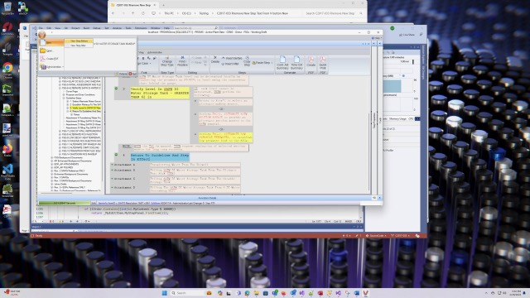

Before:
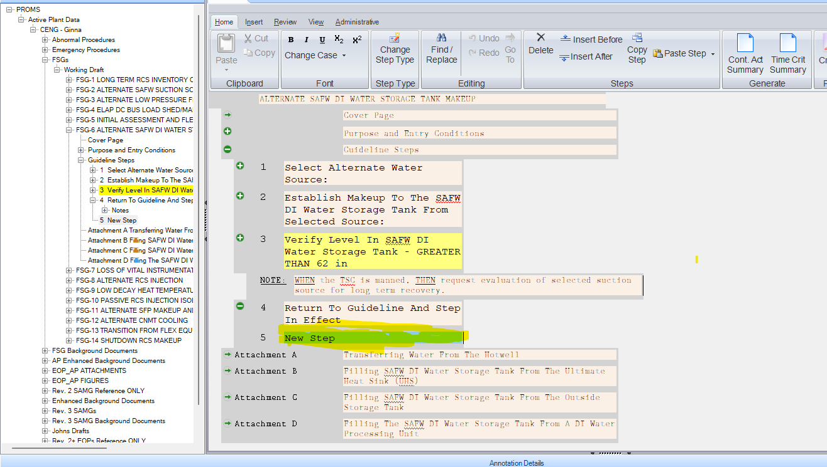
After:


