February 4, 2025

Applicability: All Plants

Internal Release Information:
C2025-011 PROMS – RO Update Admin Tool Memory Enhancements

The purpose of this upgrade is to improve the user experience when using the Admin tool to Update ROs. Currently for larger RO dbs (like Barakah) we can run up against memory constraints that do not allow all the ROs to be updated at one time. This is based upon some initial resource where some places were identified where we could improve memory usage. Some of these should benefit PROMS as a whole while others will be specific to the RO Update option in Admin Tools.

- [Check this box if a sql query or a data fix applies to this update].

Generic External Release:
Enhancement made to decrease memory consumption when utilizing the Admin Tools to Update ROs.

Plant Specific Information for Release Letter:
None

Testing Requirements:
- Use any plants data that contains a large number of ROs (Barakah is a good example)
- Open the RO Editor
- Change a RO
- Create a new RO.FST
- Exit the RO Editor and go back into PROMS
- Go to V -> Admin Tools
- Go to Links and select all procedures in the tree
- Process Links for “Update RO Values”
- It should now be able to process a much greater number of the ROs than previously.
There are a lot of factors that go into memory usage such as amount of memory a computer has and what else is running at the time.
That being said, before the change, updating all the Barakah ROs ran out of memory a little into the NOPs on my machine running nothing else (after about 20 minutes).
After this change, updating all the ROs was able to complete successfully on my machine (took about 50 minutes).
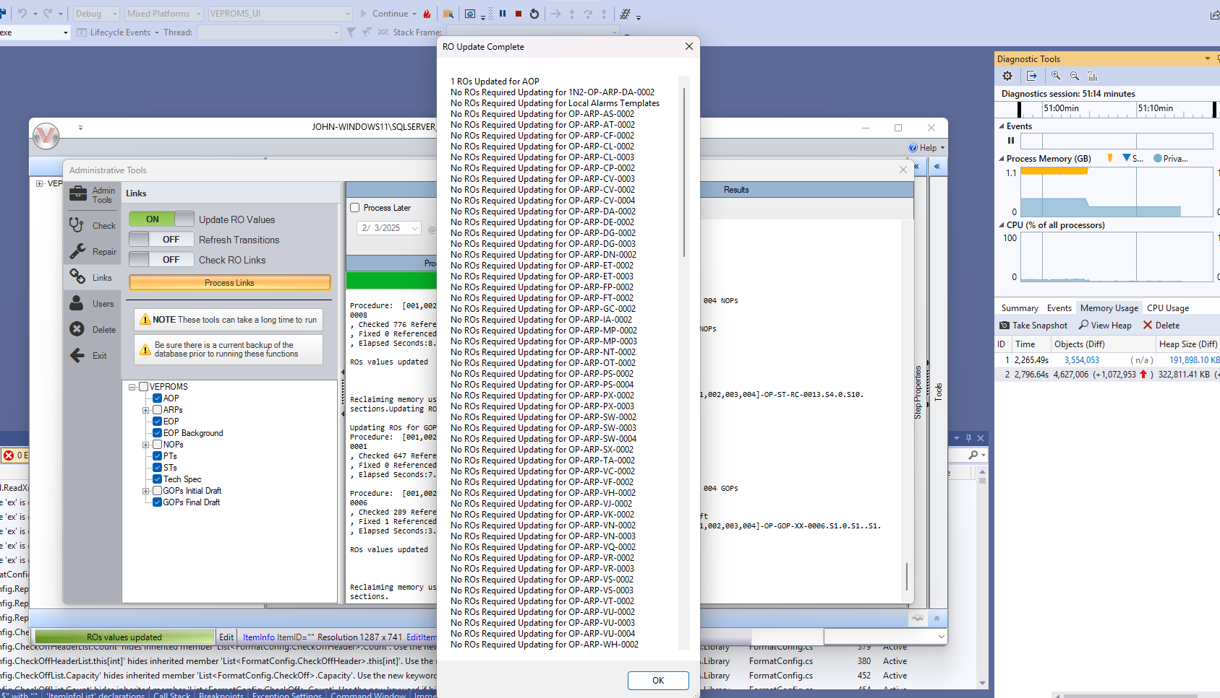

Changes/Additions to PROMS Manual and Training Videos:
[Do not use this section – for MRV/DMJ use]
- CSM submitted for PROMS User Manual: ____________.
- CSM submitted for training videos: ____________.

