July 15, 2026

Applicability: GEN

Internal Release Information:

B2026-055 – Transition Search Improvements

When performing a transition search, selecting the format does not always greying out procedure sets that do not use the format. You can still select the procedure set that should be grey out and PROMS will return results that do not correlate to the format that is selected.

For example, in Vogtle, selecting the Two Column Format should grey out the ARPs, but they remain active, except for the Locals. The search results return transitions that only apply to the Alarm Format.

Note: In PROMS, we do not load the full tree of folders for sets – we only load items as they are expanded. After discussing with Devin and John, we do not wish to change this as it could significantly impact load times in PROMS. As such, we cannot successfully “grey out” procedure sets that do not use the format when there are unexpanded folders. When Rich designed this search, he designed it such that if any folder sets are selected, they are searched (Currently the format drives what is greyed out (somewhat ineffectively) but is only considered with the search if all folders are searched). After discussion with John and Devin, will be changing the Transition Search so that if a format is selected, search results returned will only use that format.

- [Check this box if a sql query or a data fix applies to this update].

Generic External Release:
Improved PROMS Transition Search. Previously, if both a specific format was selected and specific folder sets were selected, PROMS ignored the format selection when returning search results.

Plant Specific Information for Release Letter:
None

Testing Requirements:
- Use Vogtle Data and open a procedure.
- Go to the Tools -> Search -> Transitions tab
- Select the 2 column format
- Without expanding folders, select the ARPS and search. No matches should be found.
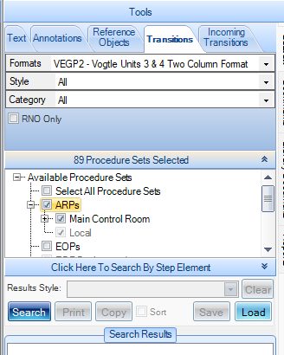

- Expand folders under ARPs. ARPS & subfolders should be greyed out.
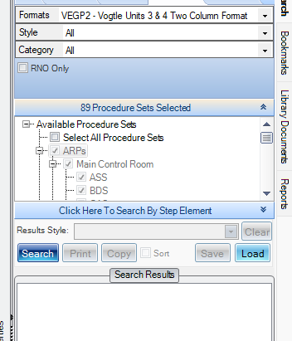
- Select the Alarm Format, enabling of procedure sets should update to reflect that format.
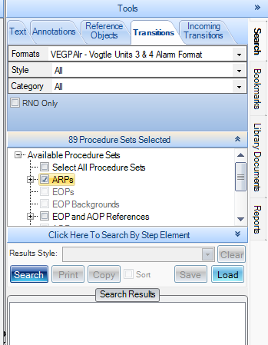
- Change the format to All – all boxes should be re-enabled.

Changes/Additions to PROMS Manual and Training Videos:
[Do not use this section – for MRV/DMJ use]
- CSM submitted for PROMS User Manual: ____________.
- CSM submitted for training videos: ____________.

