Date: 01/31/2023

Applicability: All customers

Internal Data Fixes: N/A

Internal Release:

U2024-003. Added two new links on the Help menu. One to open the error logs/export files folder (“Open Log Folder”) and the other to open the print folder (“Open Print Folder”). These links open the respective folders using the File Explorer. This would be helpful for non-computer savvy users to locate these types of PROMS files. These updates are from suggestions by Paul Linn. Updates made by Paul Larsen.

Generic External Release:

Now within PROMS there are two new links in the Help menu to make it easier to navigate to PROMS related files on your local drive. First there is a link to the log files showing error files and export files. The second is a link to your PDF printed Procedures files. The new links are in the Help Menu in the upper right corner of the application. The links are called “Open Log Folder” and “Open Print Folder”.

Plant Specific Information for Release Letter: N/A

Testing Requirements:

Test 1

- Use any database.
- Open the Help Menu in the upper right corner.
- Click on the “Open Log Folder” link.
- A File Explorer window should open to the “VEPROMS” folder in your documents folder.

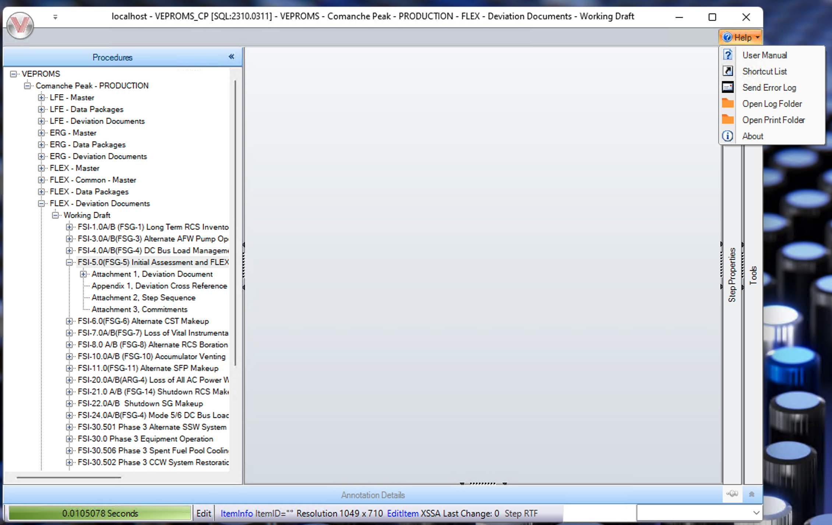
- Verify that the new “Open Log Folder” link works in the screen shot below.

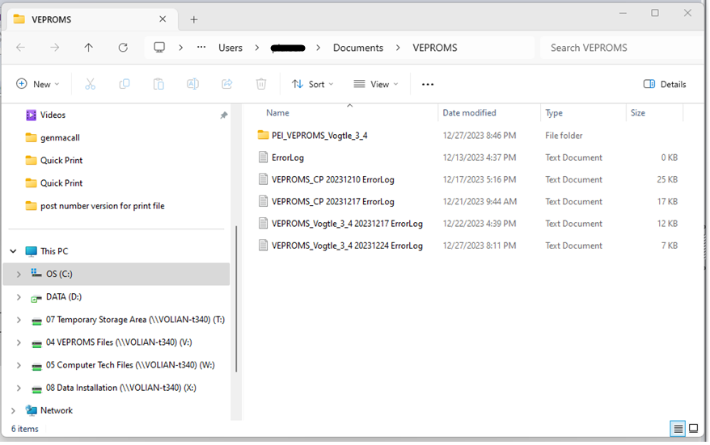

Test 2

- Open the Help Menu in the upper right corner.
- Click on the “Open Print Folder” link.
- A File Explorer window should open to the “VEPROMS” folder in your documents folder.

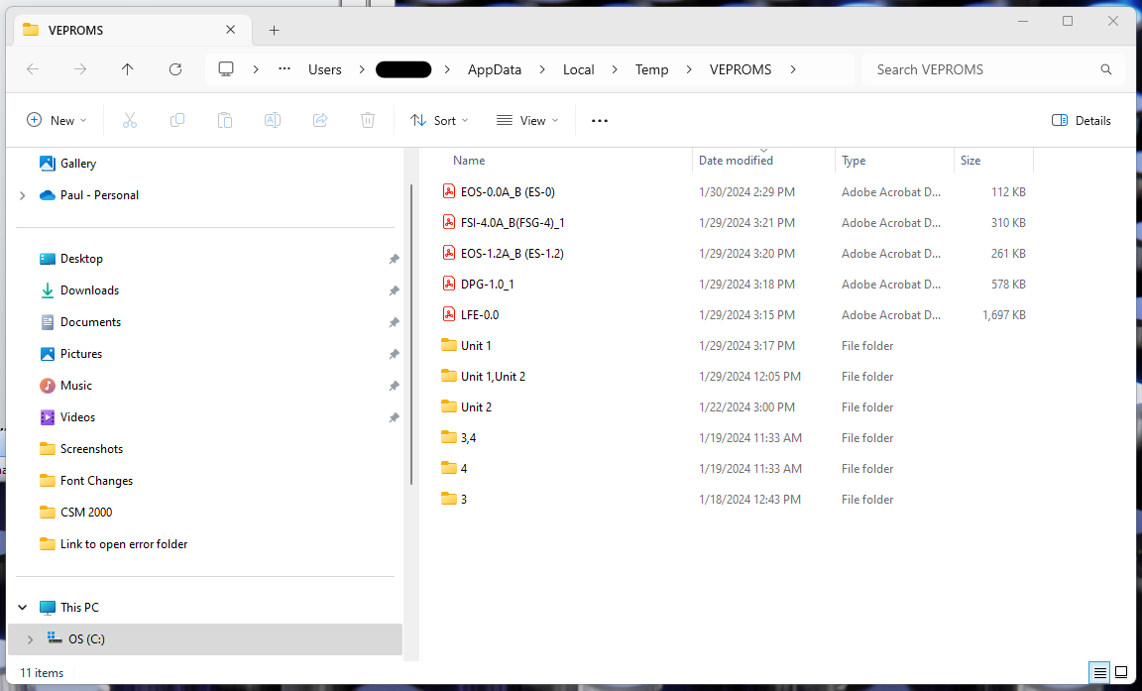

Changes/Additions to User Documentation:

Now within PROMS there are two new Help links to make it easier to navigate to PROMS related files on your local drive. First a link to the log files showing error files and export files. The second is a link to where your PDF printed Procedures files are. The new links are in the Help Menu in the upper right corner of the application. The links are called “Open Log Folder” and “Open Print Folder”.

