February 23, 2026

Applicability: BNPP

Internal Release Information:

C2026-010 Add Audit History to Setting Change Bars

This came out of the Barakah requests for changes related to Change Bars:

Currently we have an option in the tree menu for "Showing Change Bars Starting".

Would need to make changes so that selecting this action creates some kind of audit record and a method for being able to view these changes in some method of Change History.

- [Check this box if a sql query or a data fix applies to this update].

Generic External Release:
Currently we have an option in the tree menu for "Showing Change Bars Starting". This addition is to add audit information around when this option is used. From this update forward, using this option will create an audit record detailing who utilized it and when. In the History tab of the Step Properties, there has also been added a “Change Bar History” tab that details the audit information of when this option has been used (since this update). This Change Bar History will also include details of when the change bar settings were modified due to an Approval being done.

Plant Specific Information for Release Letter:
None

Testing Requirements:
- Use Barakah data ( may need to use the uncleaned Barakah data as I noticed that in the cleaned data, the Versions table was cleared).
General Instructions:
- The new Change Bar History can be viewed on the Step Properties -> History Tab
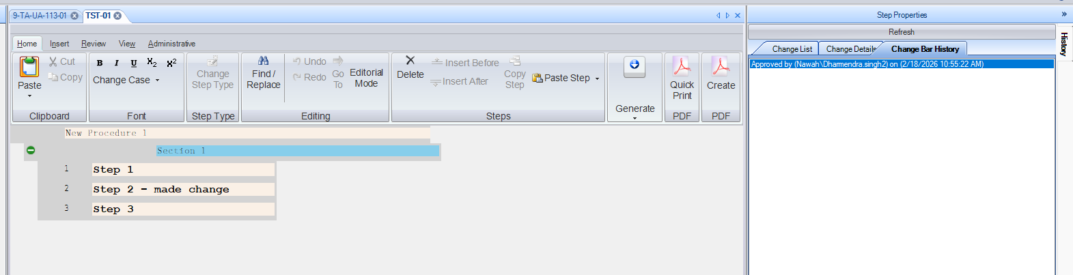
Test Case 1:
- If data previously existed before this update with all of the approval/version information, running the PROMS Update script should have pre-populated this “Change Bar History” with information from previously done Approvals.
- The wording should specify who did the Approval and when and if it was an approval for a specific unit.

Test Case 2:
- Approve a Single Unit Procedure
- The wording should specify who did the Approval and when. (Note that you may have to click on a different step in the procedure to refresh the History tab.)

Test Case 3
- Approve a Multi-Unit Procedure
- The wording should specify who did the Approval and when and if which unit it was for. (Note that you may have to click on a different step in the procedure to refresh the History tab.)

Test Case 4
- Use the “Showing Change Bars Starting ___ ” – set a date or click Today then click ok.
- The Change Bar Audit History should show the date/time that the Show Changebars was set, by whom and what date/time it had set. (Note that you may have to click on a step in the procedure to refresh the screen)

Test Case 5
- Use the Reset ChangeBars option in the “Showing Change Bars Starting ___” on a Procedure with no prior Approvals
- The Change Bar Audit History should show the date/time that the Show Changebars was set, by whom and what date/time it had set. (Note that you may have to click on a step in the procedure to refresh the screen)

Test Case 5
- Use the Reset ChangeBars option in the “Showing Change Bars Starting ___” on a Single Unit Procedure with prior Approvals
- The Change Bar Audit History should show the date/time that the Show Changebars was set, by whom and what date/time it had set. (Note that you may have to click on a different step in the procedure to refresh the History tab.)

Test Case 6
- Use the Reset ChangeBars option in the “Showing Change Bars Starting ___” on a Multi-Unit Procedure with prior Approvals
- The Change Bar Audit History should show the date/time that the Show Changebars was set, by whom and what date/time it had set for each Unit and for overall. (Note that you may have to click on a different step in the procedure to refresh the History tab.)

Changes/Additions to PROMS Manual and Training Videos:
[Do not use this section – for MRV/DMJ use]
- CSM submitted for PROMS User Manual: ____________.
- CSM submitted for training videos: ____________.

