January 23, 2025

Applicability: All Plants

Internal Release Information:
B2025-008 PROMS - Display RO Step Properties - RO Tables

When you click on a RO Table in a step, the tree view for selecting ROs is refreshing – which causes the selection to get wiped out. Adding code so if a tree refresh occurs and the item it is on is currently a RO, that it will auto re-select the item.

- [Check this box if a sql query or a data fix applies to this update].

Generic External Release:
Updated the refreshing of the selection option when selecting ROs in PROMS so that when a RO Table is clicked on in a step, that table gets selected in the RO Tree selection options.

Plant Specific Information for Release Letter:
N/A

Testing Requirements:
- Use any PROMS db that has ROs with RO Tables
- Go to a step with a RO Table (or create a step with a RO Table)
- Clicking on the RO Table, should bring up the RO in the RO Tree View
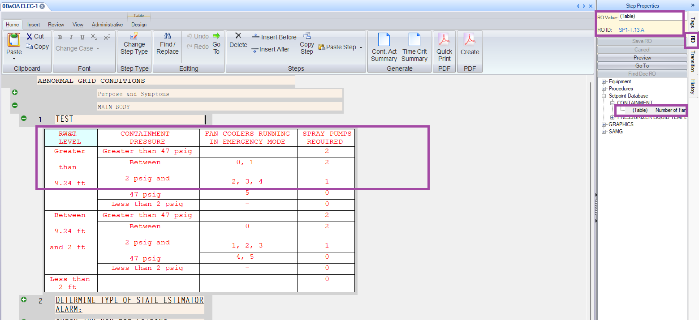

- Clicking on a step with no RO Table should bring up the full RO List

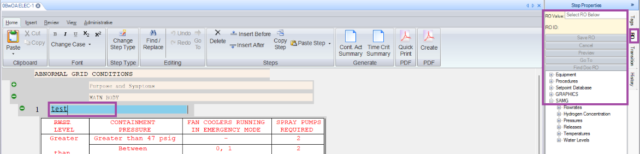

Changes/Additions to PROMS Manual and Training Videos:
[Do not use this section – for MRV/DMJ use]
- CSM submitted for PROMS User Manual: ____________.
- CSM submitted for training videos: ____________.

