January 28, 2026

Applicability: Vogtle Units 3 & 4

Internal Release Information:
B2026-009
For Vogtle Units 3&4, fixed bug where a double asterisk was place next to a continuous action RNO on the edit screen and printed with the CAS box shifted to the left.

- [Check this box if a sql query or a data fix applies to this update].

Generic External Release:
N/A

Plant Specific Information for Release Letter:
N/A – customer does not have this new feature yet.

Testing Requirements:
Use Vogtle Units 3&4 data
- Open EOP-FR-S.1 and expand step 14 in the Operator Actions section
- Verify the RNO off of sub-step 14.a has only one asterisk next to the step tab.

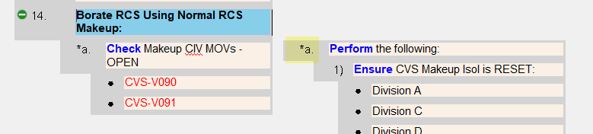

- Print the procedure and verify the CAS box is around 14.a RNO step tab

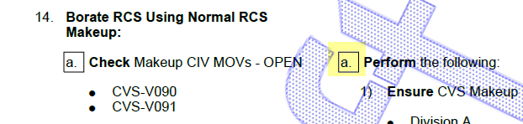
- Open AOP-302 and expand step 6 in the Operator Actions section
- Verify the RNO off of sub-step 6.a has an asterisk next to the step tab. (the include on Continuous Action Summary should be check in the step properties panel.

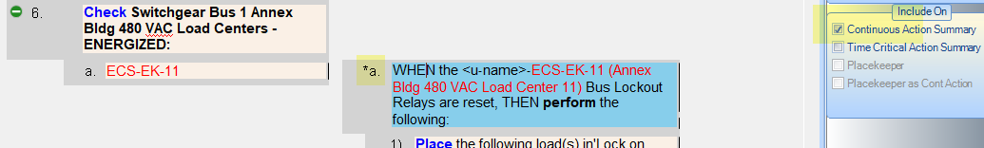

- Print the procedure and verify the CAS box is around 6a RNO step tab

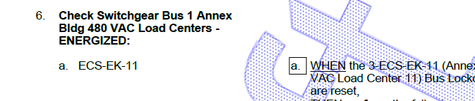

Changes/Additions to PROMS Manual and Training Videos:
[Do not use this section – for MRV/DMJ use]
- CSM submitted for PROMS User Manual: ____________.
- CSM submitted for training videos: ____________.

