August 4, 2026

Applicability: BNPP

Internal Release Information:

B2026-070 – When there is a less-then sign (<) followed by a numeric value in a Word attachment (inside of a table), PROMS thinks the user put in an RO token will generate an RO not found error in the following table row who's text contains <U-Name>.

Example: in the 001,002,003,004 NOP procedure set:
[001,002,003,004]-OP-NOP-RC-001 attachment 8
In the first column of the table look for <U-Name>-431-J-VT-0153
that <U-Name> will generate an RO not found error because of the "<0.120G" in the third column on row above it.
- [Check this box if a sql query or a data fix applies to this update].

Generic External Release:
Updated RO Resolution in Word Sections to handle a specific case where there were tables containing less than signs mixed with ROs.

Plant Specific Information for Release Letter:
Updated RO Resolution in Word Sections to handle a specific case where there were tables containing less than signs mixed with ROs.

Testing Requirements:
- Use Barakah
- Open NOP [001,002,003,004]-OP-NOP-RC-001 attachment 8
- Make a change and close and save it
- Print the Section for a Unit
- All ROs should resolve
- Edit attachment 8 – put an invalid RO in it – like <A-JUNK>
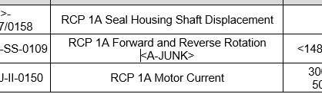
- Save it & Print the Section for a Unit
- Other ROs should resolve – that one should come up as RO Not Found
- 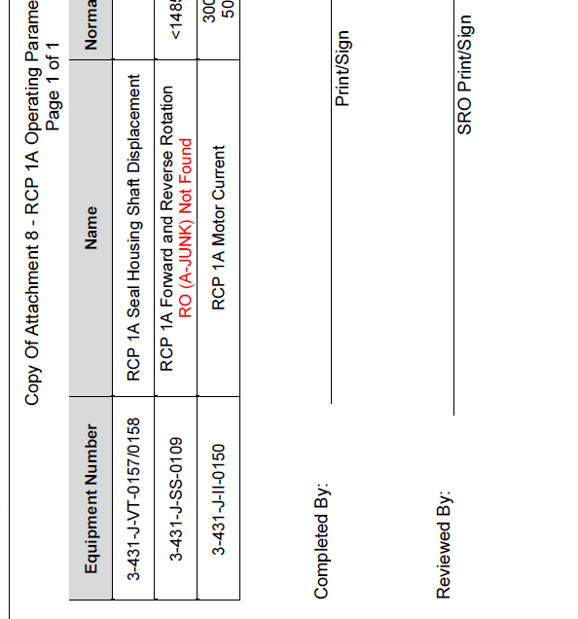

Changes/Additions to PROMS Manual and Training Videos:
[Do not use this section – for MRV/DMJ use]
- CSM submitted for PROMS User Manual: ____________.
- CSM submitted for training videos: ____________.

