December 4, 2025

Applicability: Vogtle Units 3&4

Internal Release Information:
F2025-040
Added code to adjust the position of the CAS box around the high level step number in single column attachment sections

- [Check this box if a sql query or a data fix applies to this update].

Generic External Release:
N/A

Plant Specific Information for Release Letter:
N/A – Customer does not have procedures with this issue yet – procedures currently being worked on at Volian.

Testing Requirements:
Use Vogtle Unit 3&4 data
- Print AOP procedure 3-AOP-702
- Verify the CAS box on step 19 in Attachment 1 is around the high level step

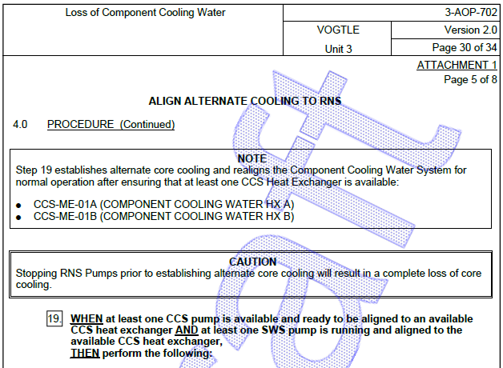

Changes/Additions to PROMS Manual and Training Videos:
[Do not use this section – for MRV/DMJ use]
- CSM submitted for PROMS User Manual: ____________.
- CSM submitted for training videos: ____________.

