June 18, 2026

Applicability: Generic

Internal Release Information:
B2026-060
B2026-061
Fixed issue where change bars were printing when they should not have been. This is related to the use of the Show Change Bars After date functionality.

- [Check this box if a sql query or a data fix applies to this update].

Generic External Release:
PROMS will now better recognized when to print a change bar, taking into consideration when the Show Change Bars Starting setting is used.

Plant Specific Information for Release Letter:
N/A

Testing Requirements:
Use Braidwood data
- In the Flex Master Set, Print Attachment A (for unit 1) in FSG-1.
- Verify there is no change bars on any of the RNO steps in step 10

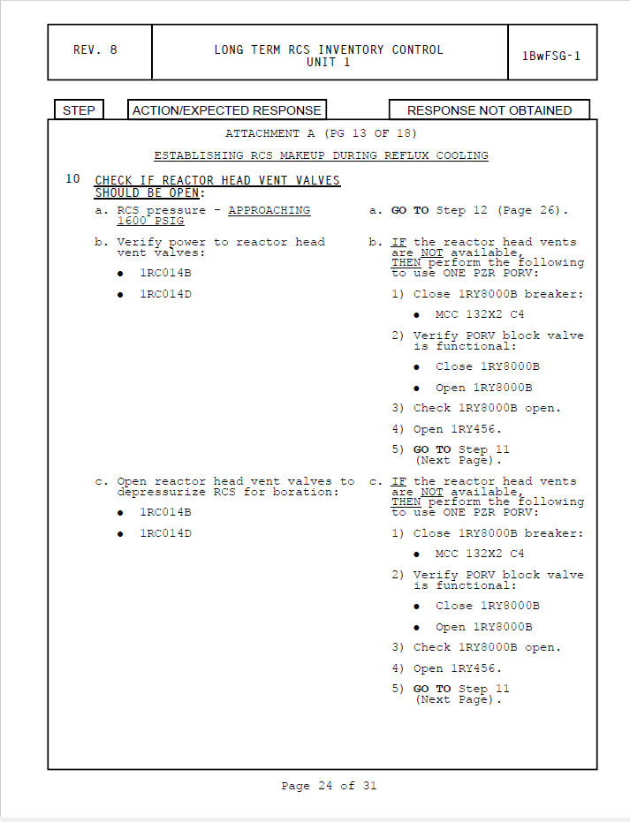

- Verify there is no change bar on step 13.e

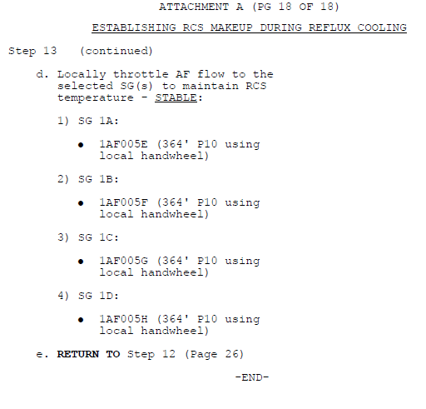

Use Byron data
- In the Flex Master Set, Print Attachment A (for unit 1) in FSG-1.
- Print FSG-5, Attachment C for unit 2.
- Verify there are no change bars on Attachment C step 2a RNO a.3

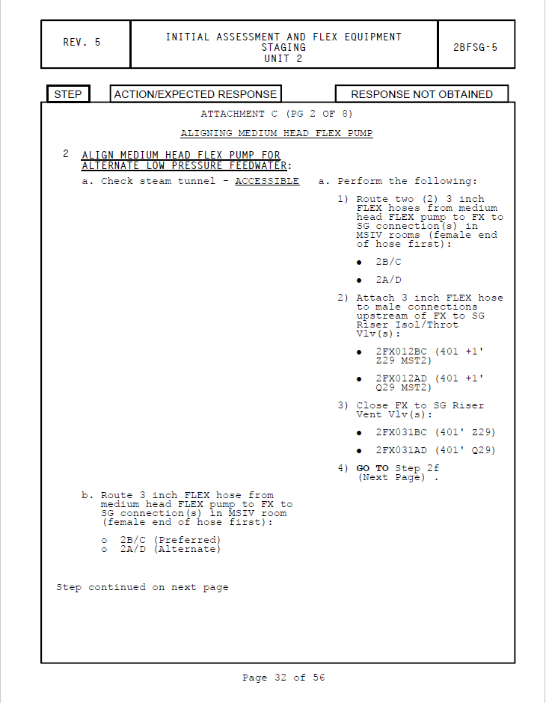
- Verify there are no change bars on Attachment C step 2d

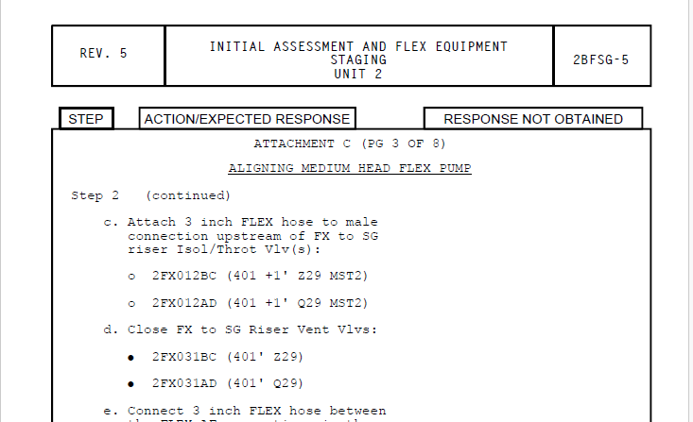

- Print procedure PRI-2 in the Abnormal Master database
- Verify there are no change bars on step 2.e (specifically page 3) of attachment A

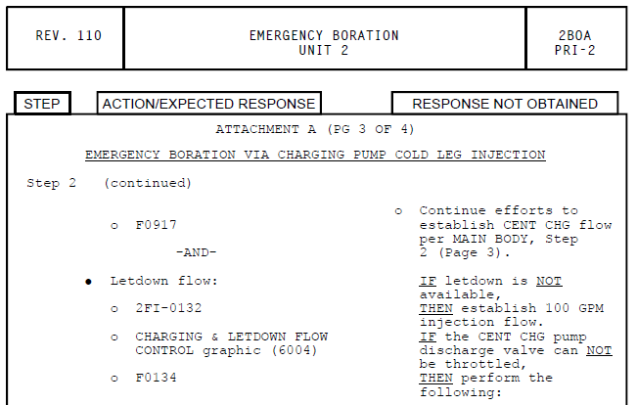

- Print procedure ELEC-1 in the Abnormal Procedures Unit 0
- Verify there are no change bars on the Symptoms and Entry Conditions page

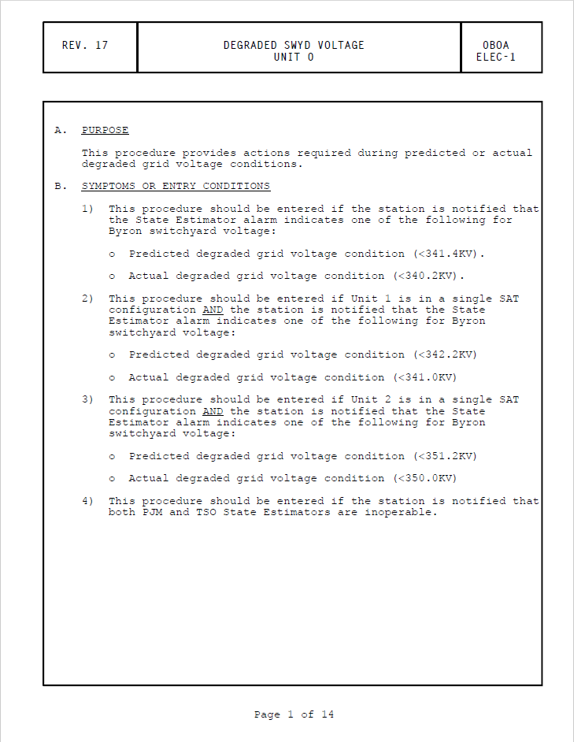

- Verify there is only a change bar on high level step 1 of the main section

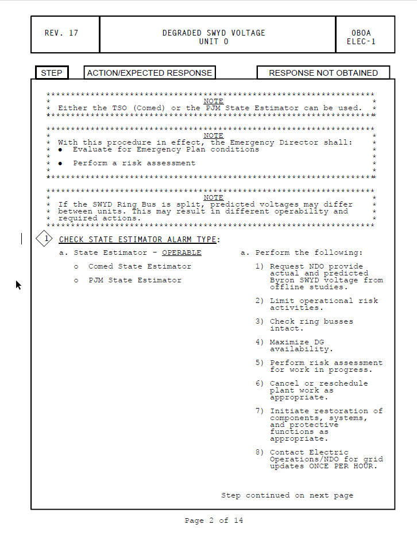

Changes/Additions to PROMS Manual and Training Videos:
[Do not use this section – for MRV/DMJ use]
- CSM submitted for PROMS User Manual: ____________.
- CSM submitted for training videos: ____________.

