July 31, 2026

Applicability: Barakah & Vogtle Units 3&4

Internal Release Information:
C2026-047
Improved the efficiency of retrieving Alarm Point Table information.

- [Check this box if a sql query or a data fix applies to this update].

Generic External Release:
N/A

Plant Specific Information for Release Letter:
Barakah
This release includes improvements in how PROMS retrieves Alarm Point Table information. The Alarm Point Table will display a little bit faster in the step editor and generating a PFD of an Alarm Point page will take a little less time.

Vogtle Units 3&4
This release includes improvements in how PROMS retrieves Alarm Point Table information. The Alarm Point Table will display a little bit faster in the step editor and generating a PFD of an Alarm Point page will take a little less time.

Testing Requirements:
Use Barakah data
- Open alarm poin AS-US-001-01 in the MCR alarm set OP-ARP-AS-001.
- Verify the alarm point table still appears (may make a few seconds)

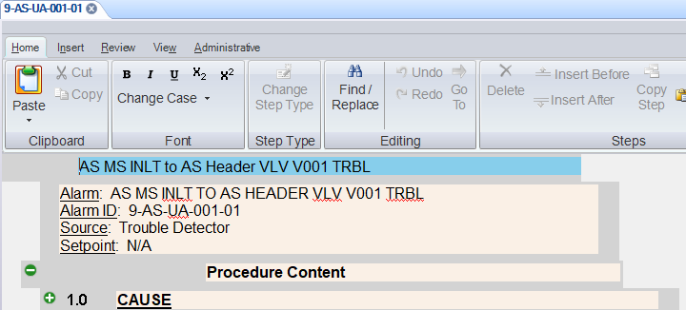

- Print the alarm procedure OP-ARP-AS-001 for unit 1 (print all from the working draft node with the merge PDF option)

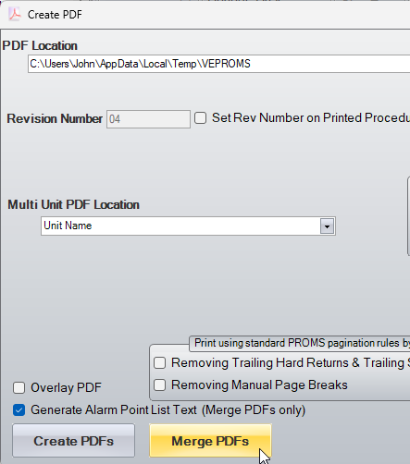

- Verify the PDF that each alarm point page has an Alarm Point Table.

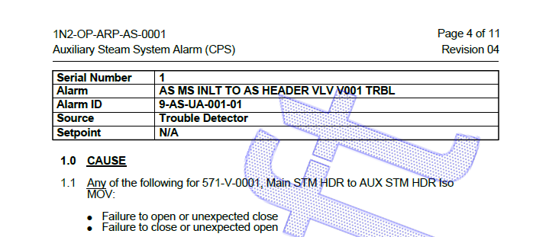

Use Vogtle Units 3&4 data
- Open alarm point CFS-ARP-001-001 in the main control room CFS alarm set.
- Verify the alarm point table still appears (may make a few seconds)
- Print do a print/merge for the CFS alarms for unit 3
- Verify the PDF that each alarm point page has an Alarm Point Table.

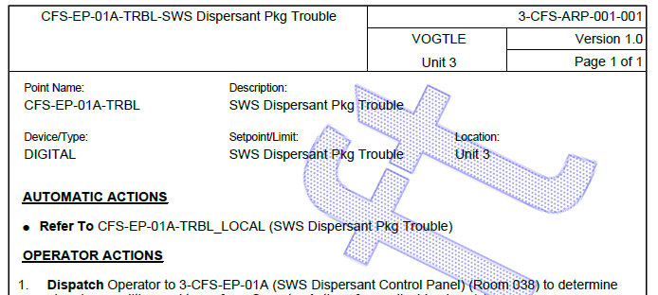

Changes/Additions to PROMS Manual and Training Videos:
[Do not use this section – for MRV/DMJ use]
- CSM submitted for PROMS User Manual: ____________.
- CSM submitted for training videos: ____________.

