February 13, 2026

Applicability: Vogtle Units 3&4

Internal Release Information:
F2026-007 - Added Landscape Attachment - Word Editor DocStyles/PageStyles to Background Document Formats.

/ F2026-009 Vogtle Backgrounds Table of Contents adjustment

Vogtle Units 3 & 4 Backgrounds - the Table of Contents section defined in the background steps format needs adjust. (VEGPBckStpsall.xml) to extend the page numbers under the Page column.

We need to copy the table of contents setting from "Vogtle Units 3 & 4 Background Document Attachments" (VEGPBckall.xml)

- [Check this box if a sql query or a data fix applies to this update].

Generic External Release:
N/A

Plant Specific Information for Release Letter:
N/A – format under development

Testing Requirements:
No Formal testing needed – these will be verified as Background Documents are cleaned up for Vogtle 3 & 4
Notes for Using this Style:
Open the Background for AOP-401B
Change the Format for Section 8 to VEGPBckStps, Section: “Landscape Attachment - Word Editor”
Will need to adjust
Number for Section 8 to TABLE 1
Title for Section 8 to FIELD COMPONENTS IMPACTED BY PLS DROP FAILURES
Number for Procedure to: <u-Name>-AOP-401-B
Title for Procedure to: Malfunction Of DDS
In Section 8 word document, first page should begin with the table and there should be no header table
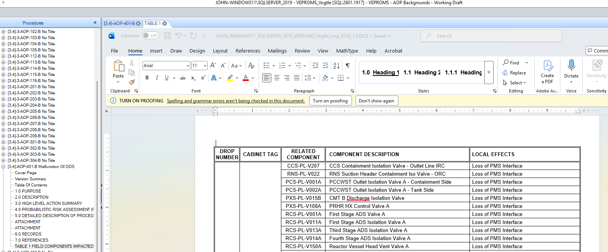
Print the background for AOP-401-B
Look at Section 8 and verify that the boxes and information shows correctly

Changes/Additions to PROMS Manual and Training Videos:
[Do not use this section – for MRV/DMJ use]
- CSM submitted for PROMS User Manual: ____________.
- CSM submitted for training videos: ____________.

