October 1, 2025

Applicability: Vogtle Units 3 & 4

Internal Release Information:
F2025-024
Turned off the automatic bolding of RNOs

- [Check this box if a sql query or a data fix applies to this update].

Generic External Release:
N/A

Plant Specific Information for Release Letter:
N/A – Part of Volian’s import of data for customer and developing PROMS format

Testing Requirements:
Use Vogtle 3 & 4 data
- Print EOP procedure E-3 for unit 3.
- Verify the high level RNO off of step three is not all bolded

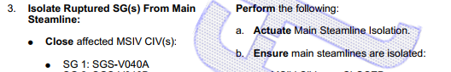

- Verify the RNO off of step 4.a is not all bolded

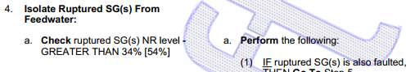

Changes/Additions to PROMS Manual and Training Videos:
[Do not use this section – for MRV/DMJ use]
- CSM submitted for PROMS User Manual: ____________.
- CSM submitted for training videos: ____________.

