May 13, 2025

Applicability: All Plants

Internal Release Information:
C2025-031
Added Tool Tip text for the Options, Exit, Manage Security, Reset Security, Update Formats, and Administrative Tools. Also adjusted the tool tip text for the Reset Options button (on the Options window) to be left justified instead of right justified.

Developer’s Note:

Besides this minor code change, I first needed to fix an issue with Dot Net Bar’s Visual User Interface Editor. Two Public Encapsulation string variables were added to the DisplayTags.cs Volian Control to populate the height and width text boxes for Image sub-step types (on the Step Properties Pannel). Dot Net Bar’s automatic code generator was adding the encapsulated string variables to the automatically generated frmVEPROMS designer file. The when Dot Net Bar’s Visual User Interface Editor tries to render, it got confused and errored out.

To resolve this, I created a function (method) that will update the height and width text boxes on the step properties page and removed the two encapsulation variables from DispayTags.cs.

- [Check this box if a sql query or a data fix applies to this update].

Generic External Release:
PROMS Main Screen
Tool tips were added on the Option and Exit Buttons, as well as, on the menu options for Update Formats, Manage Security, Reset Security, and Administrative Tools.

Plant Specific Information for Release Letter:
N/A

Testing Requirements:
Use any plant data
- Run PROMS
- Click on the V button
- Hover over the Options button and verify a tool tip pops up

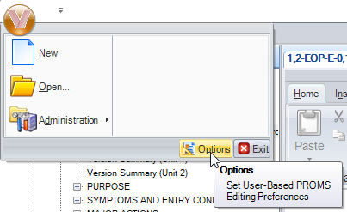

- Click on the Options button to open the options dialog
- Hover over the Default Settings button and verify the tool tip is left justified instead of right justified.

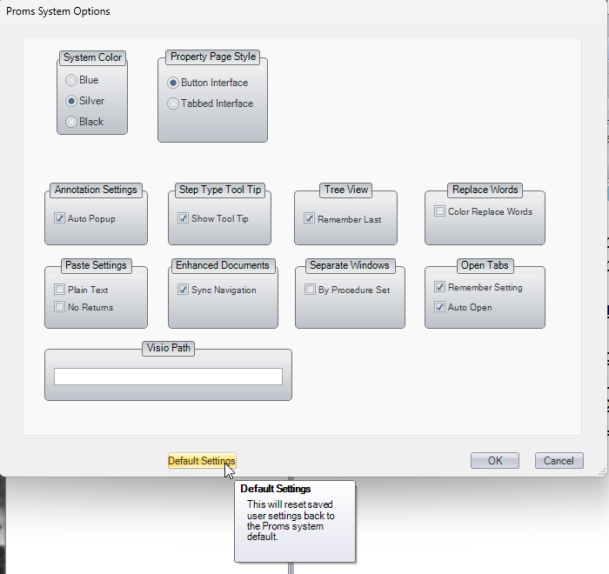

- Hover over the Exit button and verify a tool tip pops up
- Click on the Administrator button
- Hover over Manage Security and verify a tool tip pops up

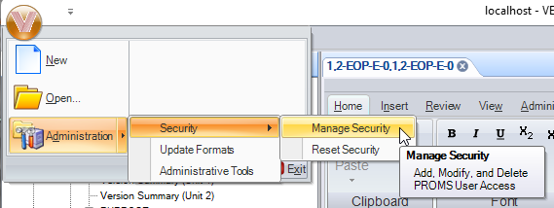

- Hover over Reset Security and verify a tool tip pops up
- Hover over Update Formats and verify a tool tip pops up
- Hover over Administrative Tools and verify a tool tip pops up

Re-Testing for inserting an Image

- Open a procedure to edit a procedure step
- Add a new image and verify the image’s height and width is shown in the step properties panel (a jpg file is located in the “V:\Proms Versions\Test Version\Data to use for testing\C2025-031” folder)

Changes/Additions to PROMS Manual and Training Videos:
[Do not use this section – for MRV/DMJ use]
- CSM submitted for PROMS User Manual: ____________.
- CSM submitted for training videos: ____________.

