October 25, 2024

Applicability: South Texas

Internal Release Information:
F2024-080 Add Initial Line/Ability to Disable to UI for South Texas

South Texas formats (OHLP, HLP, HLPFSG)). Turn on the initial line for all sub-steps and include turning it on in the RNO column.

Additionally add coding to:

- add an indicator in the editor so the user can see if a step will print with their initial line to the left of the step/sub-step tab.

- add a checkbox in the Signoff / Checkoff grouping on the Tags tab of the Step properties to allow the user to toggle the initial line Off or back On. A format flag should be added to control whether that check appears.

- if the user toggles the initial line off, then the step editor should remove the indicator next to the step tab on the edit screen.

- [Check this box if a sql query or a data fix applies to this update].

Generic External Release:
N/A

Plant Specific Information for Release Letter:
South Texas formats (OHLP, HLP, HLPFSG)). Turn on the initial line for all sub-steps and include turning it on in the RNO column. Add ability to disable the initial line for steps/sub-steps in the UI.

Testing Requirements:
- Use South Texas data – by default using OLP (procedures will need changed to test HLP & HLPFSG formats)
- By Default, line should show next to Steps, Substeps, RNOs
- Disabling line option should show in the UI if there is a line on that particular step/substep
- Selecting Disable checkbox should disable on that individual step
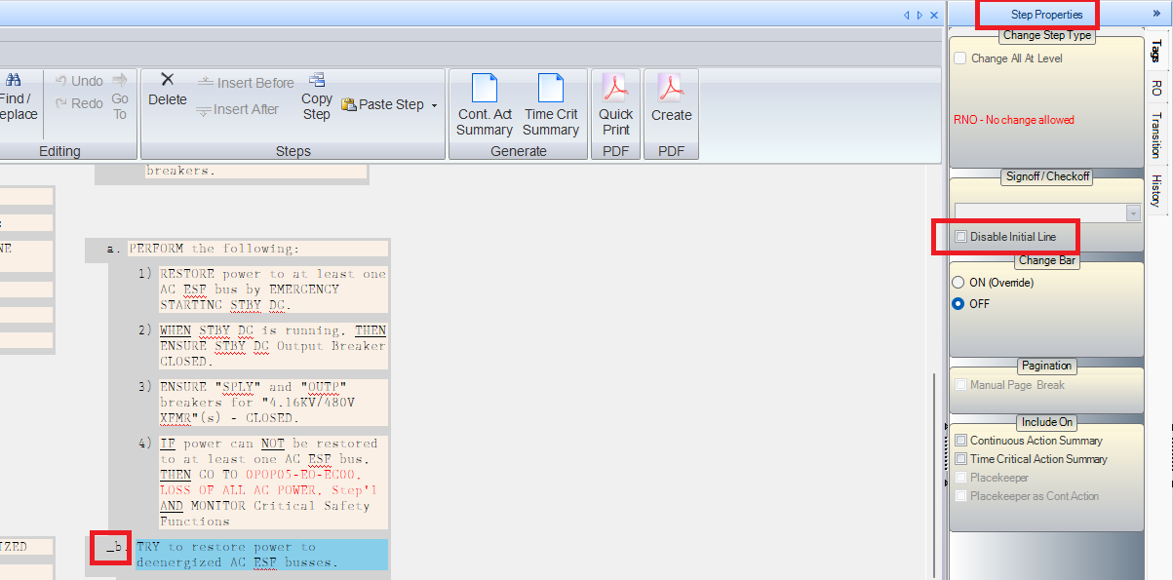

- Printing the procedure should also reflect whether or not the “Disable Initial Line” option is checked.

- Should be at least 1 negative test – Someone other than South Texas: Ensure that for them, lines do not show in UI or print, and they do not have checkboxes in UI for Disabling Initial line.

Changes/Additions to PROMS Manual and Training Videos:
[Do not use this section – for MRV/DMJ use]
- CSM submitted for PROMS User Manual: ____________.
- CSM submitted for training videos: ____________.

