May 8, 2024

Applicability: Generic – Generate PDF Links

Internal Data Fixes: N/A

Internal Release:

C2024-007
When link information is created in a PDF during print, the link information includes the PDF file name of where the link is referencing. Logic was added to include any file prefix or suffix to the PDF file name that is saved in the link information so the Adobe can locate the file and open it when the use clicks on the link in the PDF.

Generic External Release:
Generate PDFs with Links
PROMS will now properly create active transition links to procedures that append a prefix and/or suffix to their PDF file name when using the Create PDF Links switch during printing.

Plant Specific Information for Release Letter:

N/A

Testing Requirements:
Use Beaver Valley data
- Open the properties on the Working Draft node for the SD EOPs Unit 1 procedure set
- Set the PDF location to an empty folder locally on your computer – on the Output Settings tab. Save and close.

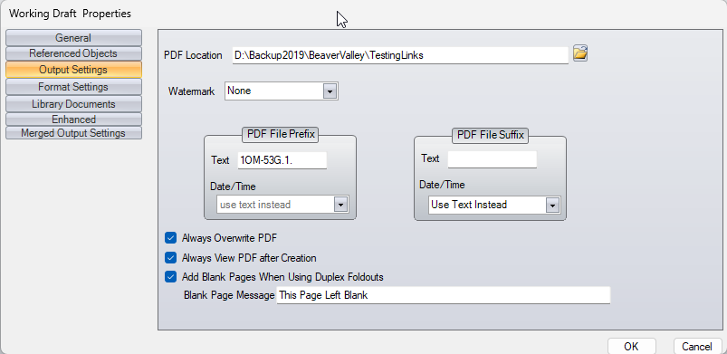

- Right click on the Working Draft again and select to print all procedures.
- On the Print dialog select to Create RO and Transitions Hyperlinks
- Click on Create PDFs

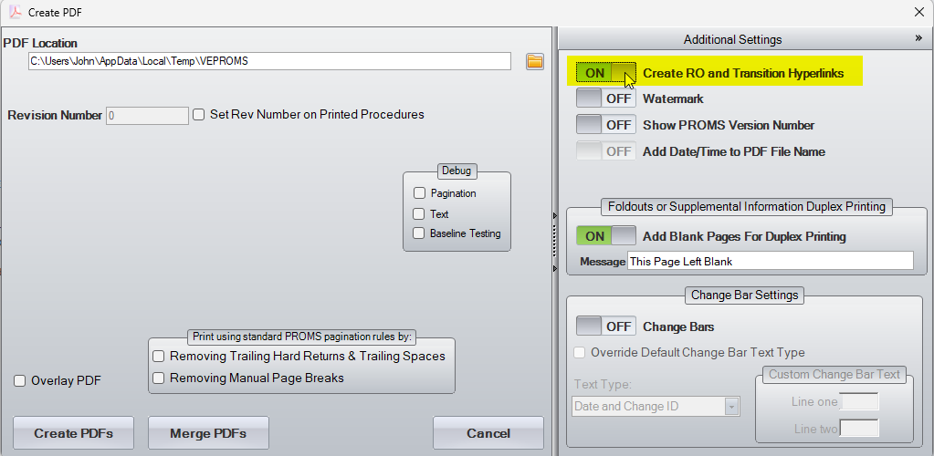

- Once it’s finished printing, open the folder containing the PDFs.
- Open the PDF 10M-53G1SD-0.pdf and click on the transition link in step 1.a RNO. (if you get a message from Adobe about trusting the document, click on allow)
- Verify the PDF of SD-4 opens to step 1.1

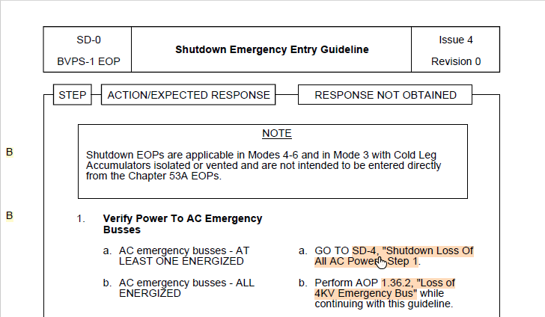

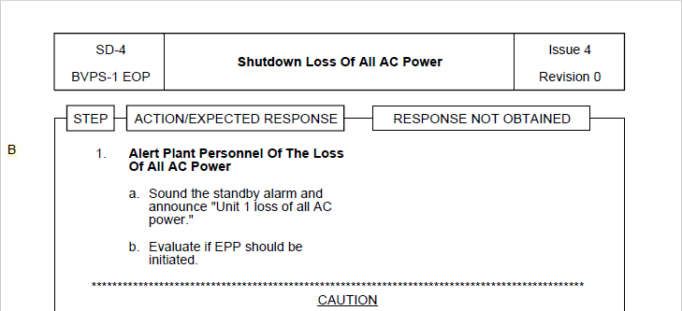

Changes/Additions to User Documentation:

N/A

