11/29/2023

Applicability: B2023-116: Vogtle Alarms – pagination issue

Internal Data Fixes: NA

Internal Release:

B2023-116: Vogtle Alarms – pagination issue. As shown below, a page break is inserted immediately after the HLS ‘OPERATOR ACTIONS’ with sub-steps starting on following page. With this fix in pagination.cs, sub-steps print on same page as the HLS.

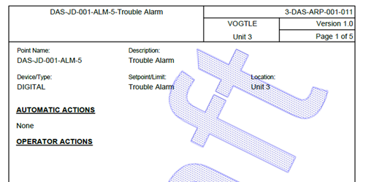

Generic External Release: NA

Plant Specific Information for Release Letter: NA - not released to customer yet

Testing Performed:

See Testing Required.

Testing Requirements:

Using the Vogtle sql database:
£ Print 3-DAS-ARP-001-011 DAS-JD-001-ALM-5 (id = 24848) to verify that the High level ‘OPERATOR ACTIONS’ has sub-steps printed below it (not on next page):
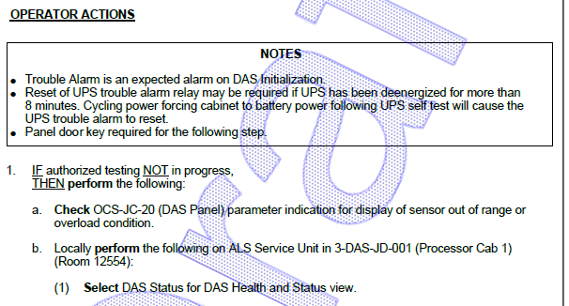

£ Print 3-DAS-ARP-001-018 DAS-JD-002-ALM-5 (id = 25093) to verify that the High level ‘OPERATOR ACTIONS’ has sub-steps printed below it (not on next page):

Changes/Additions to User Documentation: NA

