August 14, 2025

Applicability: All plants

Internal Release Information:
B2025-041Turn off overwrite PDF setting When using Quick Print
When printing with Quick Print turn offer overwrite PDF setting so users can print the same procedure multiple times.
SQL updates included.

Generic External Release:
Printing with Quick Print gives the user the ability to print the same procedure multiple times without an error.

Plant Specific Information for Release Letter:
N/A

Testing Requirements:
- USE DB VEPROMS_BeaverValley
- Open any EOP procedure.
- Click Quick Print button more than once.
- Inspect the PDF print filename.
- The file names should all be the same except the name will be postfixed with a version number.
- Make sure more than 1 file can be printed without an error message.
- USE DB VEPROMS_BWD
- Test Quick Print with the steps above for each unit in the menu and the ribbon button.
- Verify that the same procedure can be printed more than once.

Images:

PDF prints:

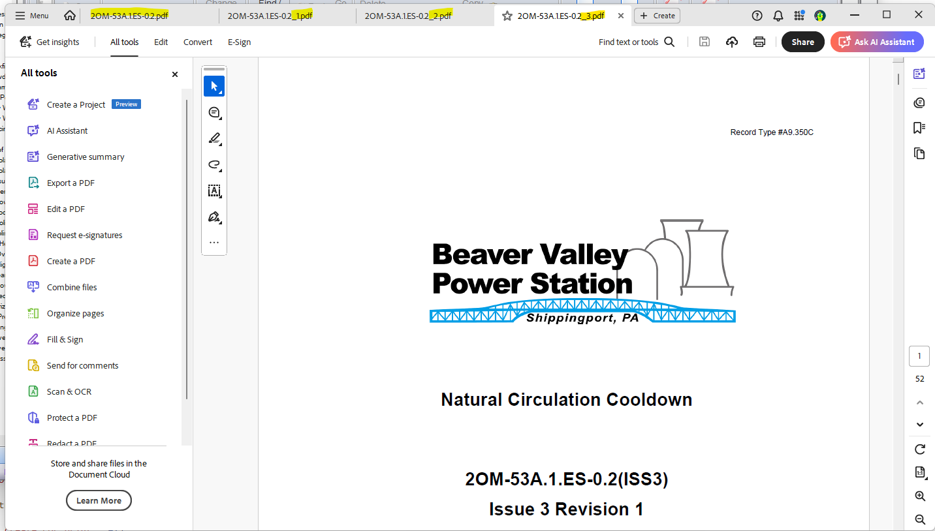

Changes/Additions to PROMS Manual and Training Videos:
[Do not use this section – for MRV/DMJ use]
- CSM submitted for PROMS User Manual: ____________.
- CSM submitted for training videos: ____________.

