October 2, 2025

Applicability: Vogtle Units 3 & 4

Internal Release Information:
F2025-025
Added the “Attachment - Single Column Step Editor” section type to the Vogtle Two Column format

- [Check this box if a sql query or a data fix applies to this update].

Generic External Release:
N/A

Plant Specific Information for Release Letter:
N/A – format under development

Testing Requirements:
Use Vogtle Units 3&4 data
- Update formats
- Expand EOP procedure ES-1.1 in the procedure tree
- Open the properties for Attachment 2
- Uncheck Print Section Number and Tiel
- Change the format to “Attachment – Single Column Step Editor” in Attachment 2 and all of its sub-sections
- Print Attachment 2 and verify is looks like example below:

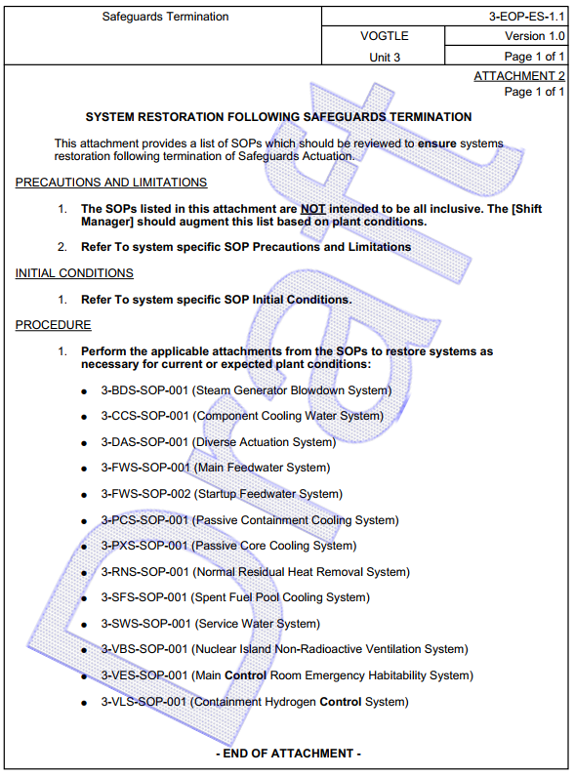

Changes/Additions to PROMS Manual and Training Videos:
[Do not use this section – for MRV/DMJ use]
- CSM submitted for PROMS User Manual: ____________.
- CSM submitted for training videos: ____________.

