September 23, 2025

Applicability: All Plants

Internal Release Information:
B2025-050
Fixed settings that required restarting PROMS and the toggle of Sync Navigation

- [Check this box if a sql query or a data fix applies to this update].

Generic External Release:
User Settings
- You no longer need to restart PROMS after changing the settings for Show Tool Tip or Color Replace Words for the changes to take effect.
- You can now uncheck the Sync Navigation checkbox to turn off the automatic positioning of the enhanced document (i.e. Backgrounds) when viewing both the source and enhanced document in split screen mode.

Plant Specific Information for Release Letter:
N/A

Testing Requirements:
Use Beaver Valley data
- Open to step 1 in procedure ES-0.0 in the Unit 1 EOPs set
- Open the Options dialog form the V button

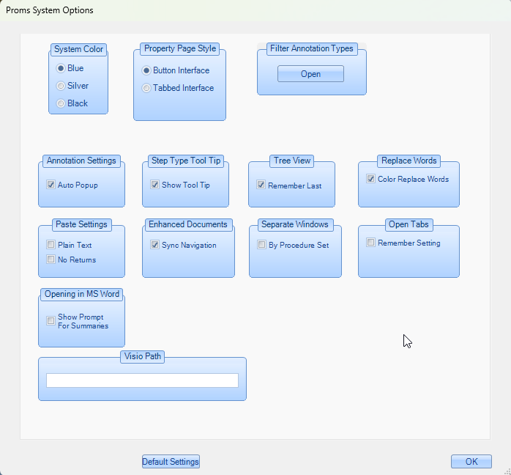

- Change the setting for Show Tool Tip (click OK)
- Verify setting change takes effect without restarting PROMS
- Change the setting for Color Replace Words (click OK)
- Verify setting change takes effect without restarting PROMS
- Open the Background for step 1

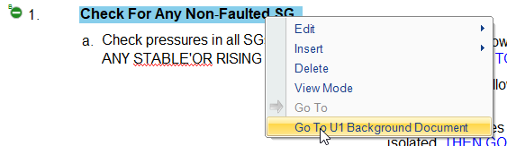
- Split the background procedure to the right of the EOP

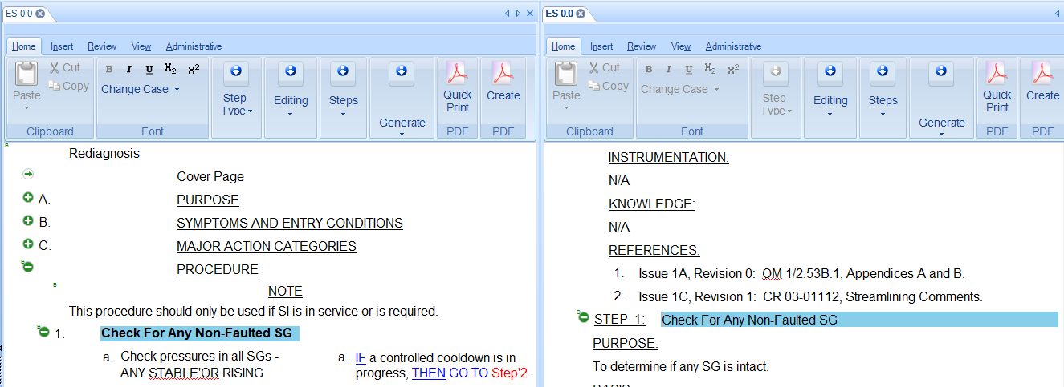

- Un-check the sync Navigation check box (click OK)
- Click on high level step two in the EOP and verify the position in the background remains on step one

Changes/Additions to PROMS Manual and Training Videos:
[Do not use this section – for MRV/DMJ use]
- CSM submitted for PROMS User Manual: ____________.
- CSM submitted for training videos: ____________.

