March 12, 2024

Applicability: Vogtle Units 3 & 4 EOPs

Internal Data Fixes: N/A

Internal Release:
F2024-016
Remove column headers from Attachment – Word Section.

Generic External Release:
N/A

Plant Specific Information for Release Letter:

N/A format under development and currently not used by the customer

Testing Requirements:
Use Vogtle data
- Update formats
- Print procedure E-0 in the EOP procedure set
- Verify Attachment 2 does not have column heaers

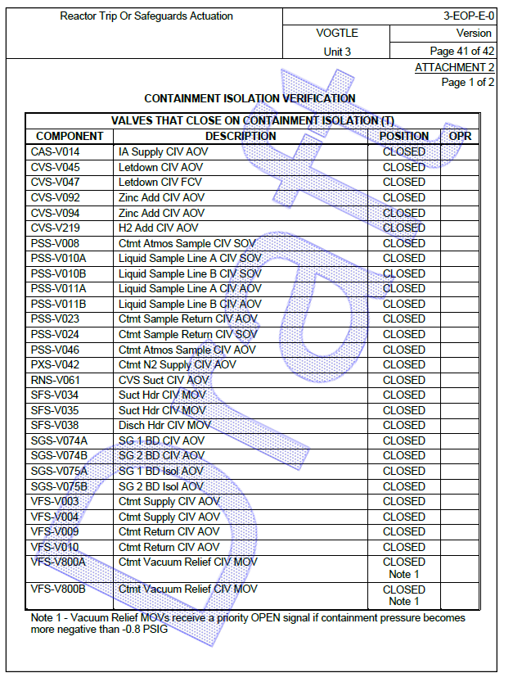

Changes/Additions to User Documentation:

N/A

