11/20/2023

Applicability: B2023-112: Search All Procedure Sets does not always work

Internal Data Fixes: NA

Internal Release:

B2023-112: Search All Procedures Sets does not always work. Also, if Search all Sets was selected and a user then unselected a particular set, Proms would crash. Changes were made to DisplaySearch.cs, a list, lstCheckedDocVersions, is used to keep track of the sets that are selected, but it is an empty list for ‘All’. Changes were made so that list size AND checkbox for ‘All’ are used to determine whether ‘All’ are selected. Note that some of coloring of Search’s procedure sets tree view nodes was commented out, it seems to not be working correctly and needs further work.

Generic External Release: NA (this just fixes some issues with Search All)

Plant Specific Information for Release Letter: NA

Testing Performed:

See Testing Required.

Testing Requirements:

Using the Ginna sql database:
£ Add some recognizable unique text (for doing search – such as tester initials) to a procedure in AOPs and EOPs. (this is a set up for testing). Exit and reenter.
£ Bring up a procedure in EOPs. Expand the search panel, add text from previous step (tester initials), select ‘Select All Procedure Sets’ and then do the search. Entries from the AOP, EOP, and the EOPs enhanced background procedure should be listed:
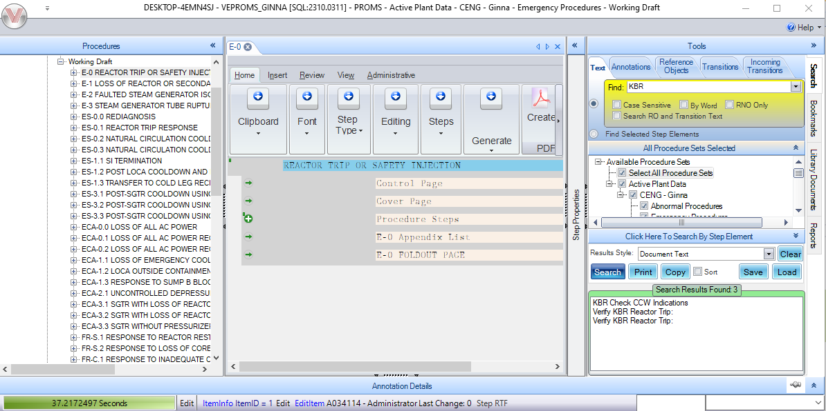

£ Expand the procedure sets tree list and unclick one of the sets to verify that the program does not crash

Changes/Additions to User Documentation: NA

