April 22, 2024

Applicability: Vogtle Units 3 & 4

Internal Data Fixes: N/A

Internal Release:

F2024-054

Added a Dashed Double Spaced List sub-step type and a Dashed Explicit OR sub-step type to the Vogtle Units 3 & 4 Two column format

F2024-055

Added "NO" to be underlined in ReplaceWords to the Vogtle Units 3 & 4 Two column format

Generic External Release:

N/A

Plant Specific Information for Release Letter:

N/A – Two Column format currently in development as Volian imports EOPs.

Testing Requirements:
Use Vogtle Unit 3 & 4 data
- Update formats
- Edit EOP procedure FR-Z.1 step 2.
- Change one of the bulleted lists to use the Dashed Double Spaced List type
- Change another bulleted list to use the Dashed Explicit OR sub-step type

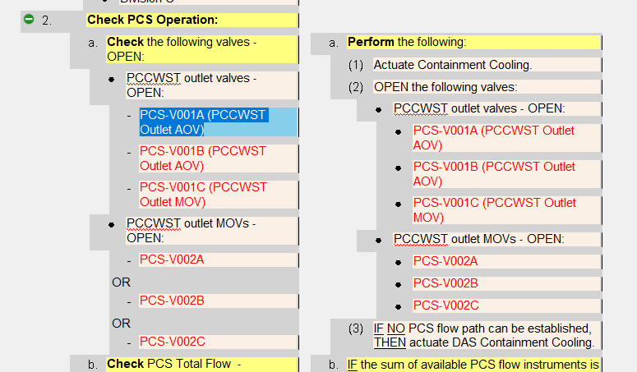

- Print the procedure.
- Verify the Dashed Double Spaced List uses a dash and puts a blank line between each item.
- Verify the Dashed Explicit OR list uses a dash and has “OR” between each item
- Verify the word NO is underlined in step 2aRNO(3)

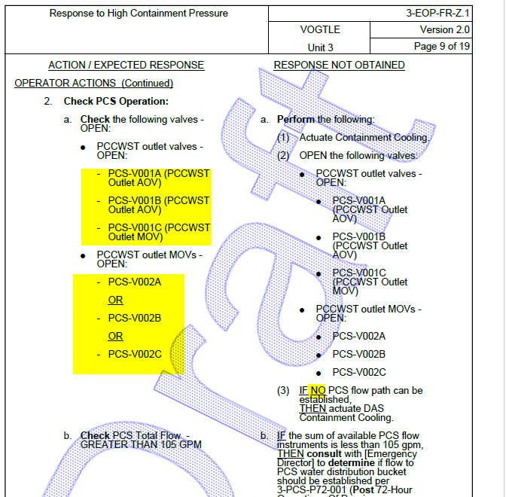

Changes/Additions to User Documentation:

N/A

