November 25, 2024

Applicability: All Plants

Internal Release Information:
B2023-095_U2022-004 - When Copy/Pasting Symbols, some of the symbols paste in an incorrect font

- [Check this box if a sql query or a data fix applies to this update].

Generic External Release:
Enhanced Copy/Paste Functionality to add additional support for when copy/pasting symbols from one PROMS step to another.

Plant Specific Information for Release Letter:
N/A

Testing Requirements:
- Use Any Plant
- Enter a mix of text and symbols into a step.
Note: There are:
- Regular symbols (like ÷)
- Greek alphabet symbols (Alpha -> Omega, both upper and lower case)
- One Baltic symbol (Energy = Ē)
- Test 1: Inserting a new step, test copy/pasting the text into the new step utilizing ctrl-c/ctrl-v
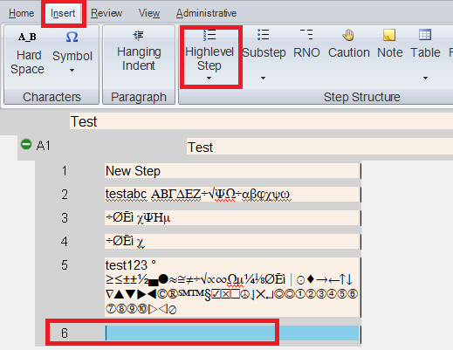
- Test 2: Inserting a new step, test copy/pasting the text into the new step utilizing the context menu
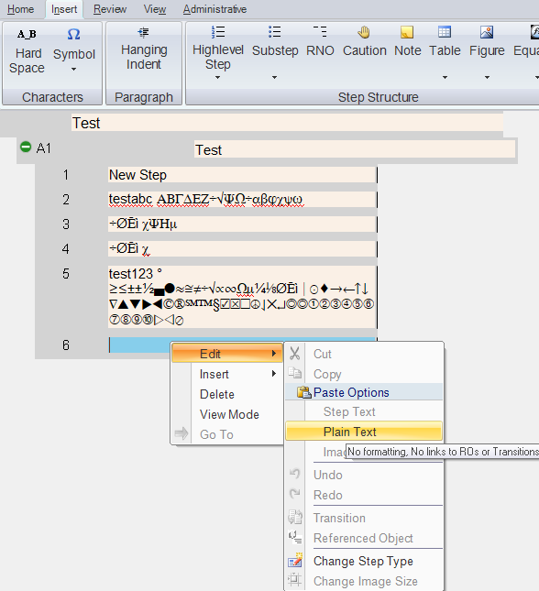
- Test 3: On an existing step with no symbols/just some text, test copy/pasting the text utilizing ctrl-c/ctrl-v
- Test 4: On an existing step with no symbols/just some text, test copy/pasting the text utilizing the context menu

Changes/Additions to PROMS Manual and Training Videos:
[Do not use this section – for MRV/DMJ use]
- CSM submitted for PROMS User Manual: ____________.
- CSM submitted for training videos: ____________.

