September 8, 2025

Applicability: GEN

Internal Release Information:
C2025-009 Added a report for tracking when a user is added into PROMS / when a user is added to specific PROMS security groups. Report can be run from the V-button->General Tools->Reports.

This is based upon a request from Cody at BGE around 1/23/2025 where Matt created a query for all of this information so that Michelle could provide him with a spreadsheet of that information.

- [Check this box if a sql query or a data fix applies to this update].

Generic External Release:
Added a report for tracking when a user is added into PROMS / when a user is added to specific PROMS security groups. Report can be run from the V-button->General Tools->Reports. This can be useful for cleaning up old users, providing user audit information for security audits, and identifying administrative users in cases where an administrator leaves the company.

Plant Specific Information for Release Letter:
N/A

Testing Requirements:
- Use Any DB
- Go to: V-button->General Tools->Reports
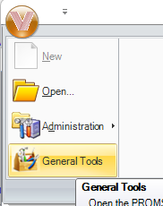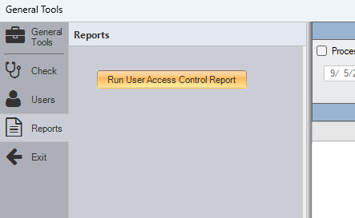
- Mousing over the “Run User Access Control Report” button should provide a tooltip description of the report
- Pressing the button should prompt the user for the name and the location to save the report.

- Opening the created excel file should provide info on when Users were added to specific groups in PROMS as well as when they were added to PROMS.
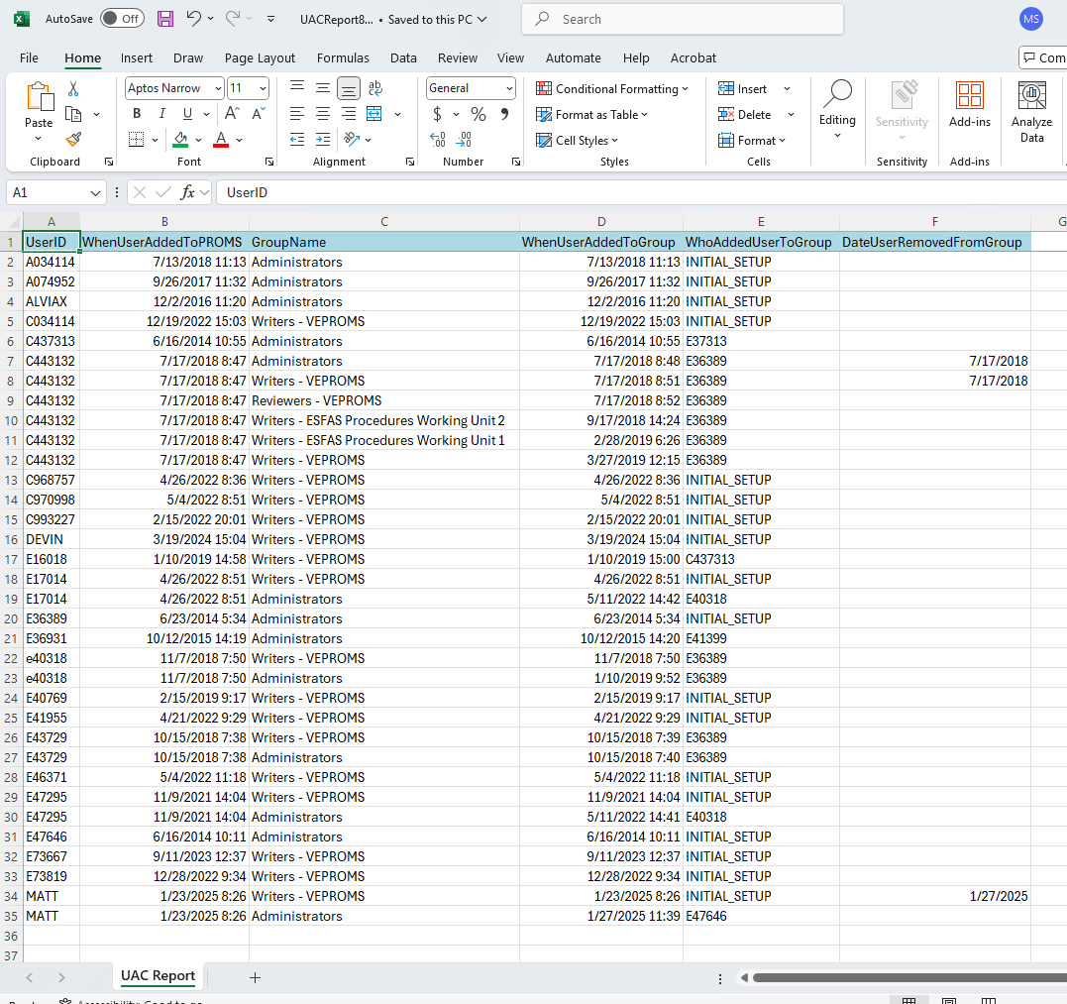

Changes/Additions to PROMS Manual and Training Videos:
[Do not use this section – for MRV/DMJ use]
- CSM submitted for PROMS User Manual: ____________.
- CSM submitted for training videos: ____________.

