Date: 1/09/2023

Applicability: All customers

Internal Data Fixes: N/A

Internal Release:

F2023-141/ B2023-114 Bettina Withers has requested that all Comanche formats be updated to use the Arial 11 font. They would like to have this in January/early February. The ERG formats are top priority. Some of the formats already use Arial 11.

Generic External Release:

The font in PROMS and in the Printed Documents for Comanche Peaks has been upgraded to Arial 11.

Plant Specific Information for Release Letter: N/A

The font in PROMS and in the Printed Documents for Comanche Peaks has been upgraded to Arial 11.

Testing Requirements:

- Use database VEPROMS_CP
- Print a random number of Procedures.
- Review each print to make sure that the font is Arial.
- Select various procedures and examine the details in the editor window to make sure that the font is Arial. The next item below is the only exception.
- Open “BSI-0.0 Safety Function and Support System Restoration”. Notice that Attachment 2 and Attachment 3 have the default font "Prestige Elite Tall". According to John this is the font the customer wants for these sections. See screen shot below.

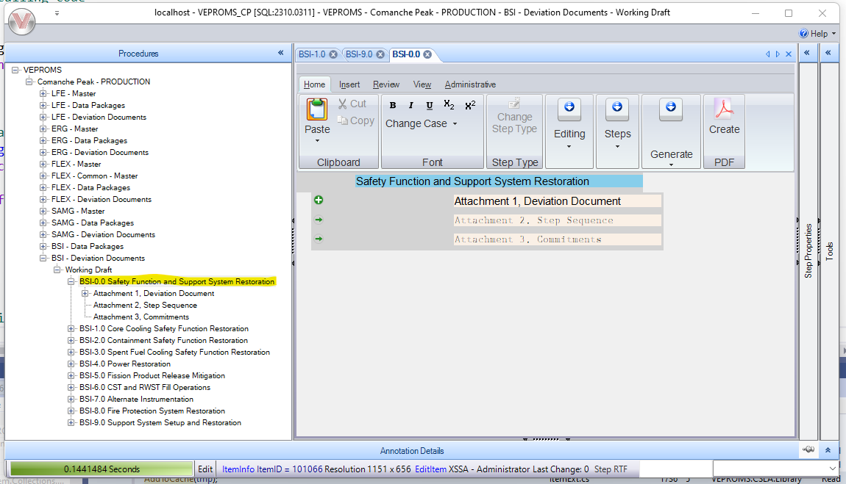

Changes/Additions to User Documentation:

Comanche Peak’s font has been updated to Arial 11 for the most part. There are a few exceptions within PROMS itself. Some table fonts are different along with a few section types.

