April 4, 2025

Applicability: All plants

Internal Release Information:
B2022-031 Add filtering for Proc and Section name from Global Search.

2 database objects were modified (Procedure: vesp_SearchItemAndChildrenNewByWord, Function: vefn_SiblingAndChildrenItemsNewByWord).

Generic External Release:
In the global search the ability to include or filter out procedure/section titles has been added. You will find in the Text tab an added checkbox labeled: “Ignore Procedure and Section Titles”. If you check this box Procedure and Section Titles will not be included in the search results.

Plant Specific Information for Release Letter:
N/A

Testing Requirements:

- Use VEPROMS_BWD DB
- Open Braidwood/Rev. 2 EOP Master Procedures.
- In the Global Search “Procedure Sets Selected” make sure under Braidwood that “Rev. 2 EOP Master Procedures” is selected.
- On the Text tab enter “Response” in the Find box. Make sure that the “Ignore Procedure and Section Titles” is unchecked. Select search. You should get about 32 results.
- Again, on the Text tab enter “Response” in the Find box. Make sure that the “Ignore Procedure and Section Titles” is checked. Select search. You should get about 12 results.
- Images:
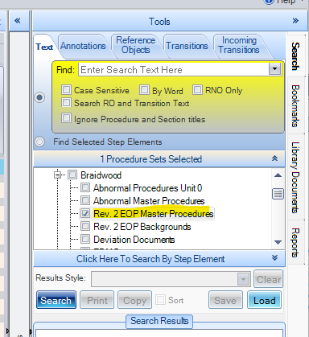

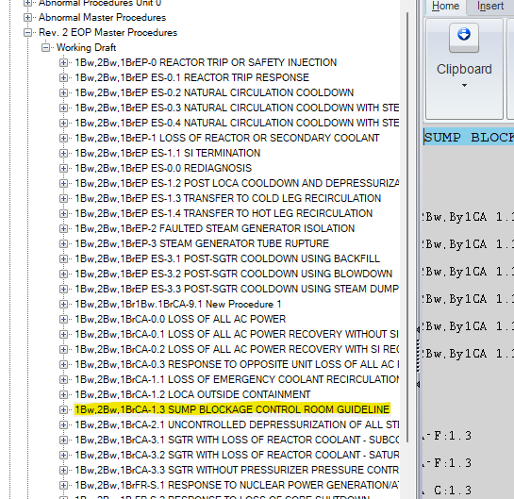

Changes/Additions to PROMS Manual and Training Videos:
[Do not use this section – for MRV/DMJ use]
- CSM submitted for PROMS User Manual: ____________.
- CSM submitted for training videos: ____________.

