April 26, 2024

Applicability: ERG format

Internal Data Fixes: N/A

Internal Release:

F2024-057
Use different symbol font for bullet for use in italic note text

F2024-058
Allow the insert of sub-steps in Notes and Cautions

Generic External Release:

Generic EOP (ERG) format
- PROMS will now print the bullet symbol when it’s in italicized text
- PROMS will now all the insert of sub-step in Notes and Cautions

Plant Specific Information for Release Letter:

N/A

Testing Requirements:
Use the ERG Rev 4 data
- Update formats
- Insert a bullet symbol in Note text (Note are in Italics)
- Add a Note and a Caution to a procedure step
- Verify you can insert a sub-step off of the Note and Caution
- Print and verify the note that has the bullet symbol character prints with the symbol character

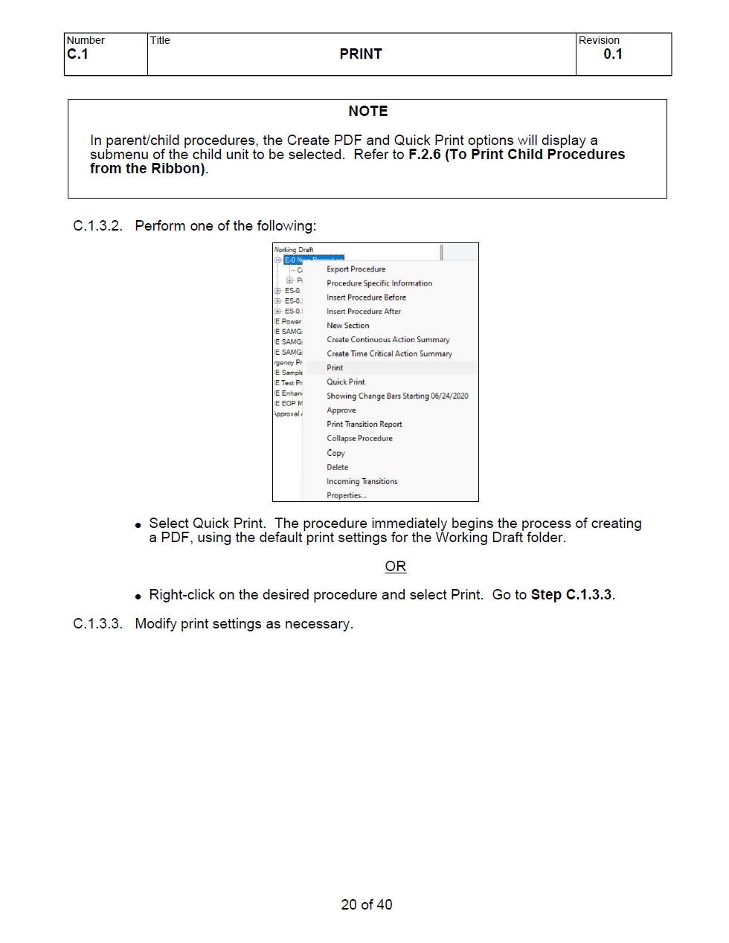

Changes/Additions to User Documentation:

N/A

