VEPROSM User Interface
DlgPrintProcedure.cs
line 62, need comment, with CSM item number, explaining change

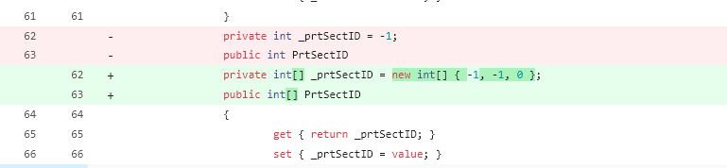

line 430-432, the comment got shifted over to the right
- Also lines 533-535, 568, 727-728, 776, 962-964

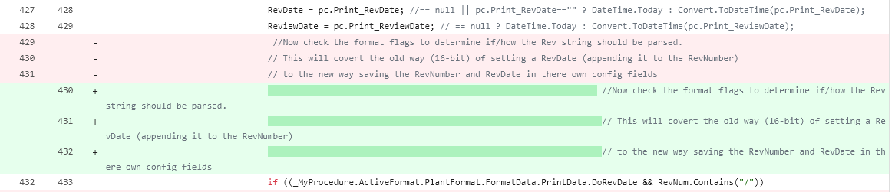

frmPDFStatusForm.cs
Line 94, need comment, with CSM item number, explaining change

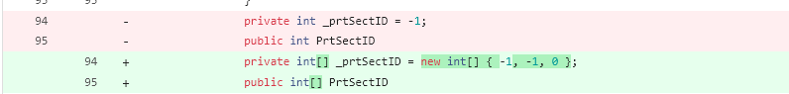

frmVEPROMS.cs
Line 1200, need comment, with CSM item number, explaining change

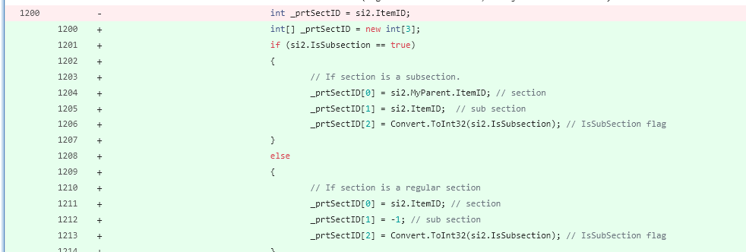

Volian.Controls.library
vlnTreeView.cs
Line 2806, the comment got shifted over to the right
Also line 2835, 2882

Volian.Print.Library
PromsPrinter.cs
line 182, need comment, with CSM item number, explaining change
Also line 362, 364, 380, 816, 836, 839, 849, 986, 1639, 3022

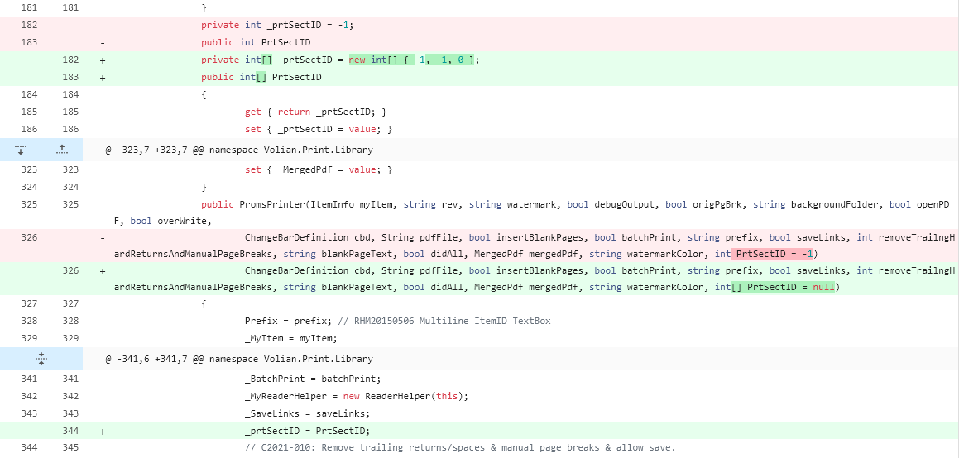

VlnPageHelper.cs
line 88, need comment, with CSM item number, explaining change

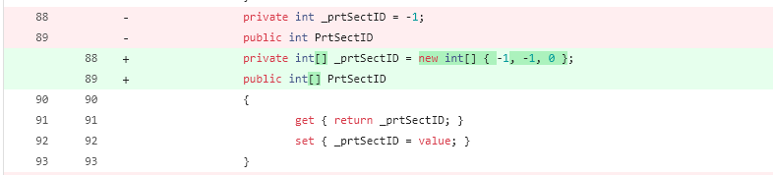

Lines 265-266, the comment got shifted over to the right
- Also lines 1372-1373

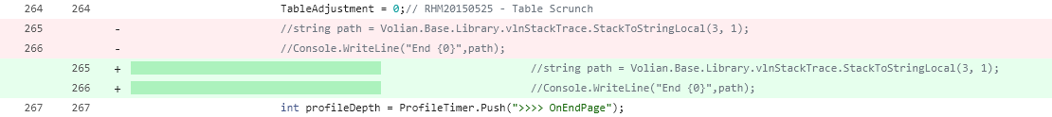

vlnParagraph.cs

*** in general - after review this file I didn't see any changes need for for this update.
*** Please verify and if no changes were made (for this update) please resore your local file and remove this from the update
*** Otherwise, below is list of areas that need resovoled - especially the Unicode charater issue.
*** The characters that got switched to Unicode should be plain ascii characters
*** Is there a setting in Visual Studio that is not correct?

Line 1 – remove Unicode character [U+FEFF]
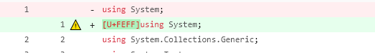

Line 271 - the comment got shifted over to the right
Also Lines 422-424, 768-769, 962, 977, 1125-1130, 1211, 1457-1459, 1503-1506, 2084-2085

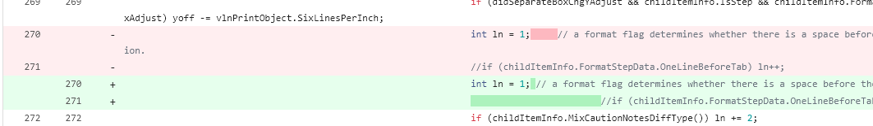

Line 2838 - remove unicode character [U+0095] (was a bullet character to a astrisk *)

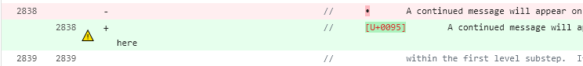

Line 2841 - remove unicode characters [U+0095] (was a bullet character to a astrisk *)
Line 2842- remove unicode characters [U+0093] & [U+0094] (were a double quotes)
Line 2843- remove unicode characters [U+0093] & [U+0094] (were a double quotes)
Line 2844 - remove unicode character [U+0095] (was a bullet character to a astrisk *)
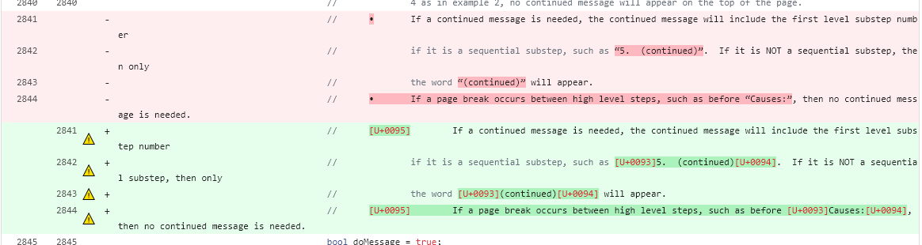

Line 2973-2975 - the comment got shifted over to the right
Also Lines3036-3040, 3058, 4002-4005, 4081

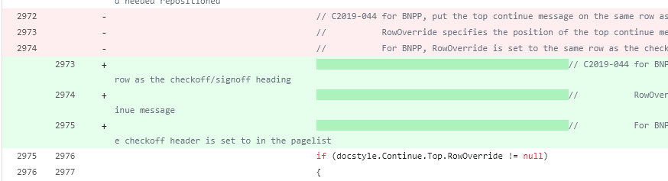

Line 4496- remove unicode character [U+0092] (was a single quote character)

Line 4874 - the comment got shifted over to the right
Also line 5378

Lines 5805 - 5817 check formatting of comment

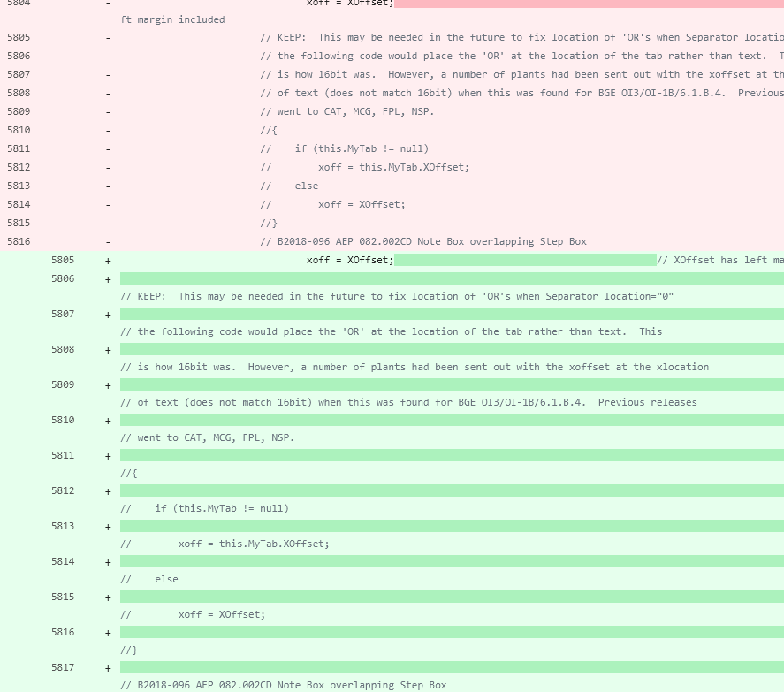

Line 6254-6256 - the comment got shifted over to the right



