November 13, 2023

Applicability: Beaver Valley

Internal Data Fixes: N/A

Internal Release:
F2023-142
Customer requested to change the indent of steps for the “Attachment with Section Number and Title – steps adj left (includes END msg)” in the “Beaver Valley Single Column Format with Issue Number (BVPS1)”.

Generic External Release:

N/A

Plant Specific Information for Release Letter:

Beaver Valley
The “Attachment with Section Number and Title – steps adj left (includes END msg)” section in the “Beaver Valley Single Column Format with Issue Number (BVPS1)” format will now indent the steps like they are in the “Beaver Valley Single Column Format (BVPSAtch)” format “Attachment with Section Number and Title – steps adj left (includes END msg)” section.

Testing Requirements:

Use Beaver Valley data
- Update formats
- Print procedure FSA-1 in the Unit One Flex procedure set
- Verify the step number tabs in the Enclosures are indented as in the sample below:

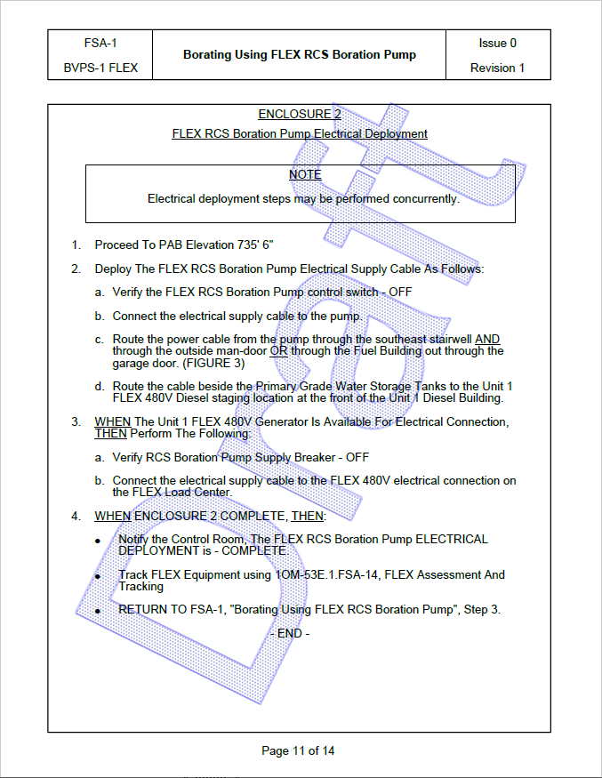

Changes/Additions to User Documentation:

N/A

