February 20, 2025

Applicability: WEP

Internal Release Information:
B2025-015 RO Editor - PROMS will get stuck in a loop (hang) while placing RO.FST information in the plant database (loading RO's) when Unit Values contain brackets. Example is Point Beach data.

Some of Point Beach RO's have curly braces in the RO return value for the units in P/C. Found this on some (5-7) Annunciator RO values. The definition of the return value (multiple return values) uses curly braces so PROMS cannot distinguish between brackets being part of a unit value or part of the format for multiple return values.

Equipment Designation, Main Steam (MS), Annunciators have examples of return values with curly braces. Look at the Referenced Object Definition on the Annunciators tree node for the definition of the return value.

- [Check this box if a sql query or a data fix applies to this update].

Generic External Release:
N/A

Plant Specific Information for Release Letter:
N/A

Testing Requirements:
- Use Point Beach Data and the ROs that have the brackets in them at:
Active Project Files\Point Beach PROMS Delivery\2025\DATA\EVALUATION\RO\
- ROEPU.7z
- RORev2.7z
Note these will both have 2015 dates on them
- Open the RO Editor and create a new FST file.
An Example of one that was previously causing problems (in the EPUs):
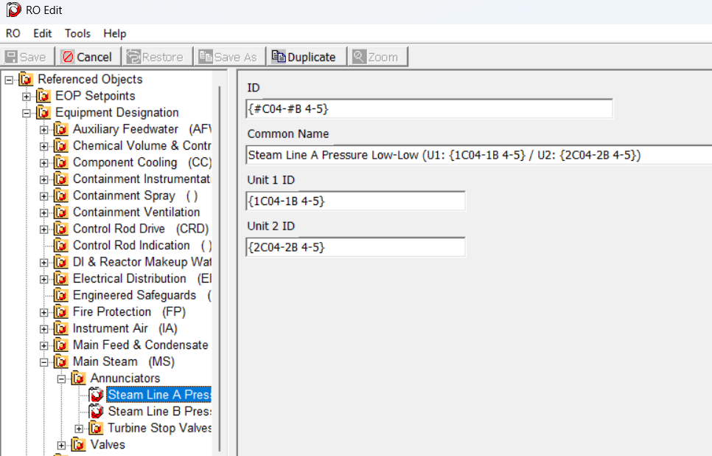
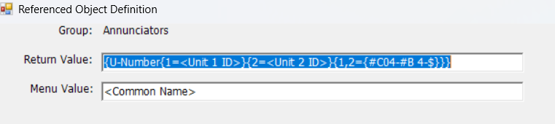
- Once have the RO.FST will need to load it in PROMS
- Note: If you are using the non-fixed version (.bak file) of the Point Beach Data and you try to open a procedure it may hang & crash / loop because it is trying to read the old RO data and you have not yet loaded the new FST.
I found that if you go to properties on the Working draft and update the RO DB location and click update RO values then it will load your new RO.FST (without trying to open the existing ones first)
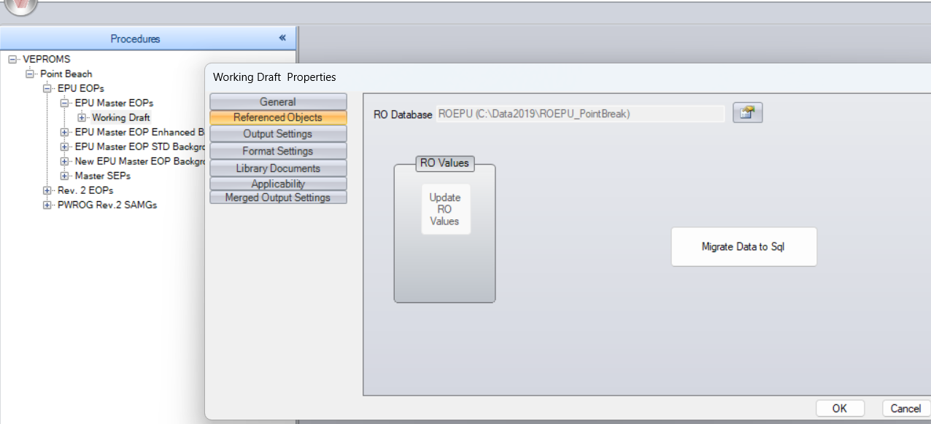

- The data should now load successfully and you should be able to open procedures.
- When looking at RO values, you should see the brackets in the default values, for example:
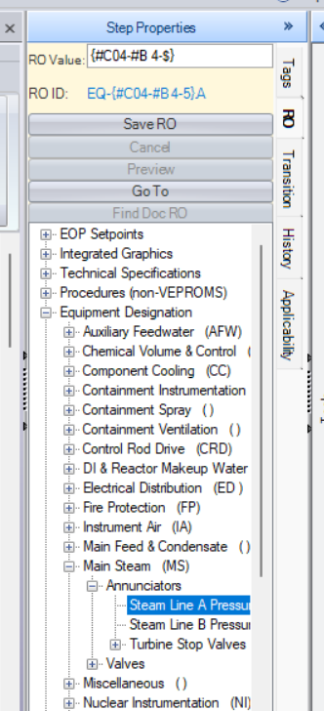

Changes/Additions to PROMS Manual and Training Videos:
[Do not use this section – for MRV/DMJ use]
- CSM submitted for PROMS User Manual: ____________.
- CSM submitted for training videos: ____________.

