April 27, 2025

Applicability: All plants

Internal Release Information:
C2025-027
Develop a way to filter annotations so the user can view only the types they want to see.

SQL updates included.

Generic External Release:
Users now can select a list of annotation types to display from the whole annotation types list. The filtering is applied on the Procedure level by right clicking a Procedure name in the left navigation tree and choosing “Select Annotations”

Plant Specific Information for Release Letter:
N/A

Testing Requirements:
- USE DB VEPROMS_BWD
- Right click on a Procedure name in and choose “Select Annotations”.
- The Select Annotations selection box will appear. On the right is the full list of Annotation Types.
- Down the center are buttons to move types between the two list boxes.
- Select a type on the left and click the button with greater than sign.
- This will move the type to the left box.
- Select a few more types and each one to the left box.
- Take a screen shot of the “Select Annotation Types” Dialog window. You will use this screen shot to compare with the
- Click the update button (to save the choices) then the cancel button to close the form.
- Now open the procedure you selected and click in a step and open the Annotation form.
- In the Type: drop down box you should see only the list that the user had previously selected in the “Select Annotation Types” dialog box.

Images:

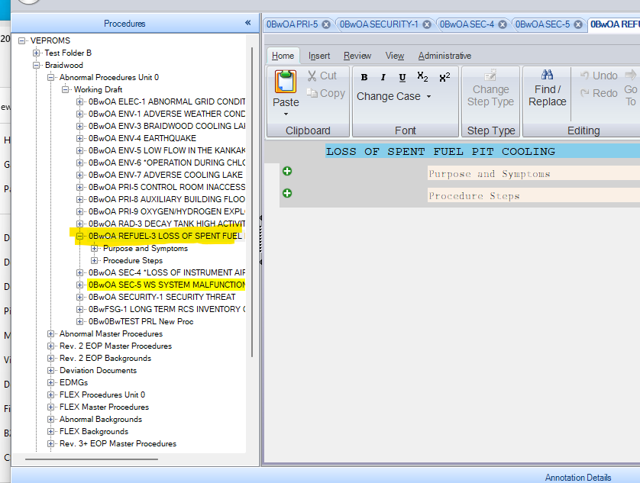

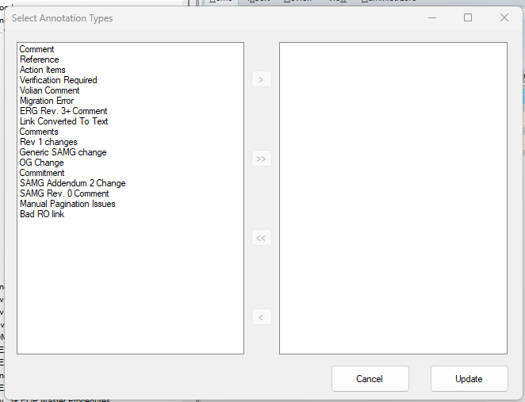

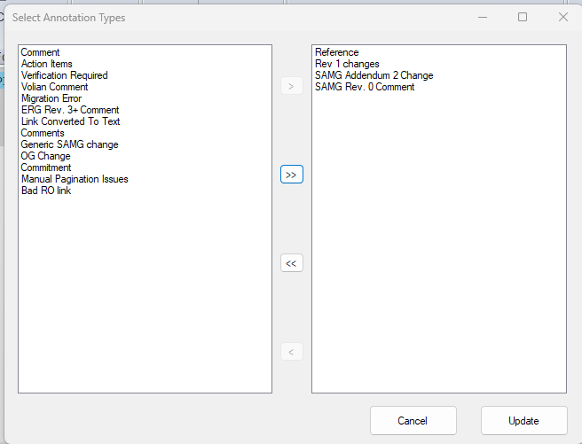

Changes/Additions to PROMS Manual and Training Videos:
[Do not use this section – for MRV/DMJ use]
- CSM submitted for PROMS User Manual: ____________.
- CSM submitted for training videos: ____________.

