September 11, 2024

Applicability: Farley

Internal Release Information:
F2024-071
Added new list of action verbs to the Replace Words so that they are bolded and removed THEN from Replace Words per Farley’s request.

F2024-072
Added sub-section types "Attachment with Sub-Sections - Single Column" and "Attachment with Sub-Sections - Two Columns" to the "Farley EOP/AOP Format"

F2024-073
Changed the page number for attachment section to be numbered with the procedure and added the attachment page numbering after the attachment section number

- [Check this box if a sql query or a data fix applies to this update].

Generic External Release:

N/A

Plant Specific Information for Release Letter:

Farley

All formats:
Added the list of action verbs to the formats so that those words are automatically bolded and disabled the word “THEN” from being automatically bolded.

Farley EOP/AOP Format
Added sub-section types "Attachment with Sub-Sections - Single Column" and "Attachment with Sub-Sections - Two Columns" for use with attachments that have sub-sections

Testing Requirements:
- Use Farley data
- Update formats
- Import the procedure from V:\Proms Versions\Test Version\Data to use for testing\F2024-071 - 072 -073
- Verify the pagination for Attachment 1 is set to “Separate”

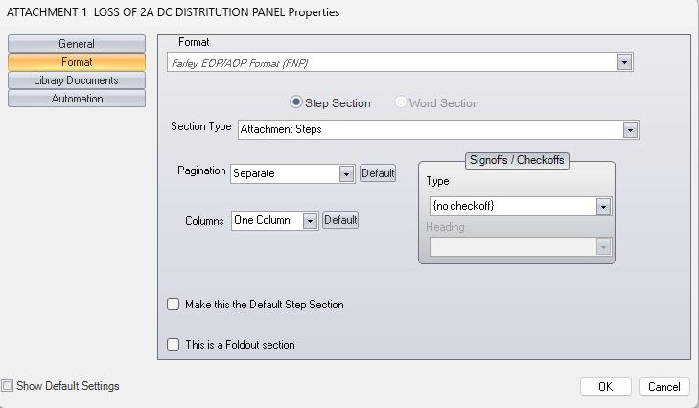

- Verify the Purpose, Symptoms or Entry, and Operational Concerns sub-sections in Attachment 1 are set to “Attachment with Sub-Sections - Single Column and the pagination is set to “Continuous”

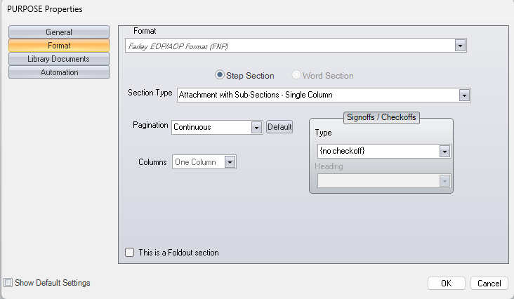

- Verify the Procedure Steps sub-section in Attachment 1 is set to “Attachment with Sub-Sections – Two Columns” and the pagination is set to “Separate”

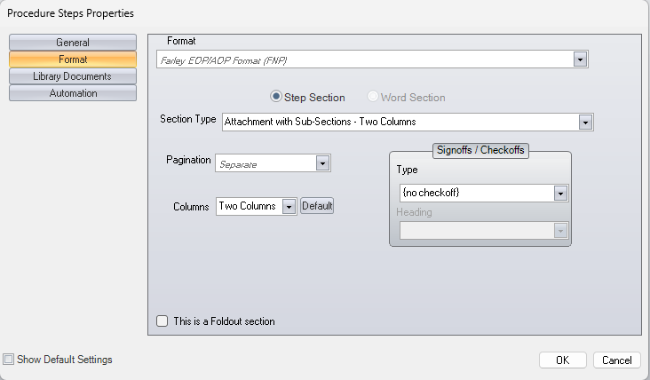

- Print that procedure and verify “perform” “Trip” and “GO TO” are bolded on the first page of the procedure steps section

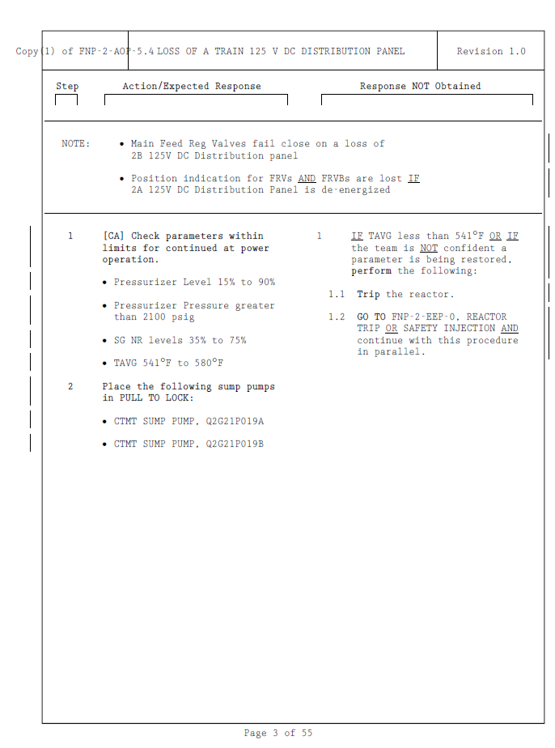

- Verify Attachment 1 has the attachment page number next to the section number and the procedure page number is at the bottom of the page and the attachment as a whole is numbered with the procedure

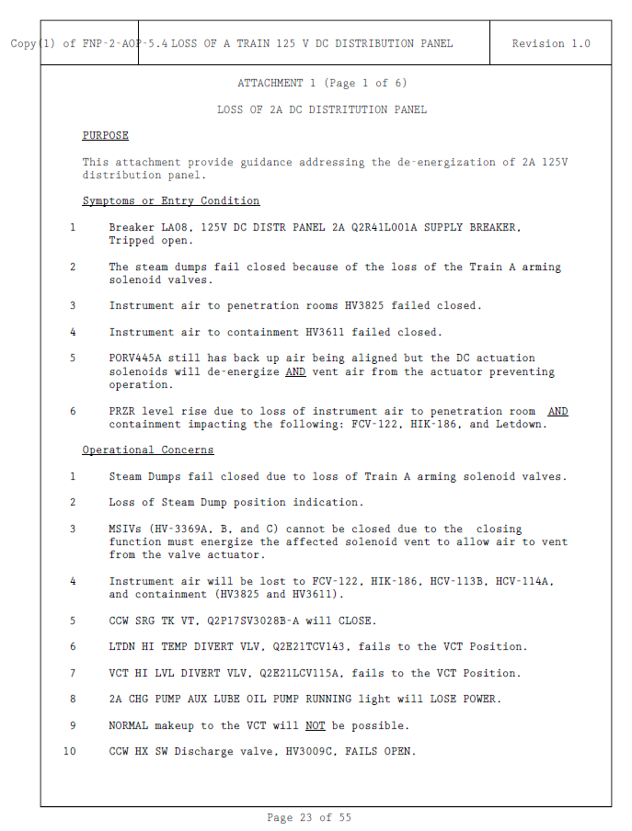

Changes/Additions to PROMS Manual and Training Videos:
[Do not use this section – for MRV/DMJ use]
- CSM submitted for PROMS User Manual: ____________.
- CSM submitted for training videos: ____________.

