8/24/2023

Applicability: B2023-089: Search results – reselection of search results step that was deleted causes unexpected results when redisplayed in editor

Internal Data Fixes: NA

Internal Release:

B2023-089: Search results – reselection of search results step that was deleted causes unexpected results when redisplayed in editor. This occurs when a search is performed, a step/procedure is displayed from search results selection from list, copy/paste/delete of the step is done in editor, a different step/procedure is displayed from search results selection, and then the deleted step is selected from the search results (the original procedure was still displayed in the editor, but not the active panel). A message stating that the step is not editable was displayed and the newly pasted step was no longer there. The change was made to the search results selection code that brings up a step in the editor, it now checks if the step is deleted, and if so, the code uses the step’s procedure to determine what is displayed in the editor.

Generic External Release: NA

Plant Specific Information for Release Letter: NA Initial Work

Testing Performed:

See Testing Required.

Testing Requirements:

Using the Vogtle sql database that is found in V:\Proms Versions\Test Version\Data to use for testing\B2023-089:
£ Open a procedure, ARP-001-001, in the ARPs/Main Control Room/MSS system
£ Do a global search for “5. “ (two blanks after the period). It should find 32 locations
£ Go to the first one. Do a copy step (it will be sub-step (1)). Go to Step 4 and do Paste Step After
£ Go back to the step you copied and delete that step
£ Go to another item in search results, then back to the first item
£ Verify that the editor is positioned on the procedure title – the step no longer exists so cannot be displayed. You should not get a message box that step is not editable. Scroll down to verify that the step that was pasted is there and the deleted step is not.

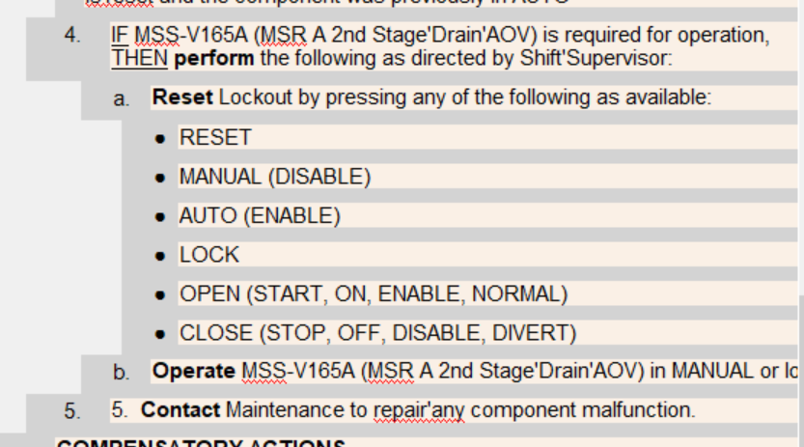

Changes/Additions to User Documentation: NA

