September 4, 2025

Applicability: Generic - Upgrade

Internal Release Information:
C2025-017
Added an option to print (generate) all of the current Approved versions of PDFs and place them in a user specified folder

- [Check this box if a sql query or a data fix applies to this update].

Generic External Release:
PROMS now has the option to print the current approved version of all of the procedures in a procedure set. This option is available via a right mouse click on the Woking Draft tree node on the Procedure tree and selecting Print All Approved Procedures

Plant Specific Information for Release Letter:
N/A

Testing Requirements:
Use Beaver Valley data
- Expand the Procedure Tree to the EOPs Unit 1 Working Draft.
- Right click on the Working Draft node and select Print All Approved Procedures.

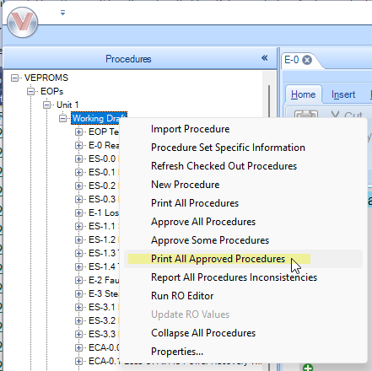

- A dialog pops up with a default folder path in the user’s Documents folder

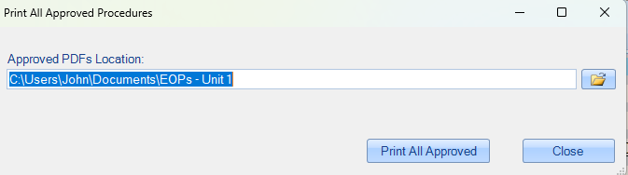

- Verify you can manually edit the folder path
- Click on the folder button (to the right of the folder path) and verify a dialog opens to allow you to select a different folder location
- Select the Print All Approved button
- Verify a message box displays showing the number of Approved PDFs that were generated and a list of procedures that were never approved

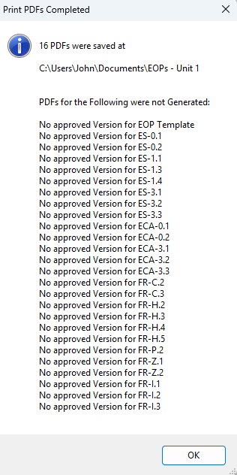

----------------
Use Braidwood data
- Expand the Procedure Tree to the Rev.2 EOP Master Procedures - Working Draft.
- Right click on the Working Draft node and select Print All Approved Procedures for Unit 2.

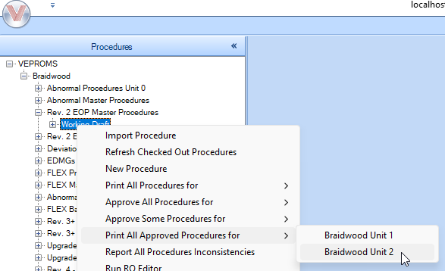

- Select the Print All Approved
- Verify the three PDFs that were generated are unit 2 procedures (open the generated PDFs)

----------------
Use Comanche Peak data
- Expand the Procedure Tree Comanche Peak Production – ERG - Master - Working Draft.
- Right click on the Working Draft node and select Print All Approved Procedures for Unit 2.
- Verify the results a problem with procedure CSF-STREESB.pdf (this happens to be a bad Approved PDF)

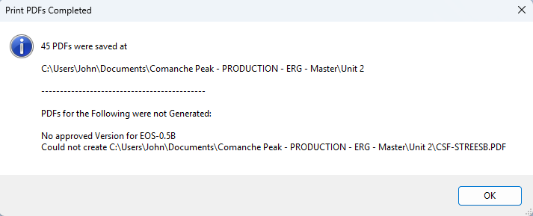

Changes/Additions to PROMS Manual and Training Videos:
[Do not use this section – for MRV/DMJ use]
- CSM submitted for PROMS User Manual: ____________.
- CSM submitted for training videos: ____________.

