April 4, 2024

Applicability: ERG format

Internal Data Fixes: N/A

Internal Release:

F2024-049
Generic EOP Format, added an un-numbered high-level step, high level step with parenthesis tab, and turn on the printing of section number and title
F2024-050
Generic EOP Format, add bullets on multiple notes and cautions

Generic External Release:

Generic EOP Format
- Added an un-numbered high level step type
- Added a high-level step type with parenthesis tab
- Added bulleted to multiple Notes and Caution items

Plant Specific Information for Release Letter:

N/A

Testing Requirements:
Use ERG Rev 4 dat data
- Update formats
- Open procedure E-0 and expand the Purpose section
- Change the step type to Un-Numbered Step
- Insert a new sequential sub-step under the Un-Numbered Step and verify the tab for that sub-step is a number has a ‘)’ instead of a period.

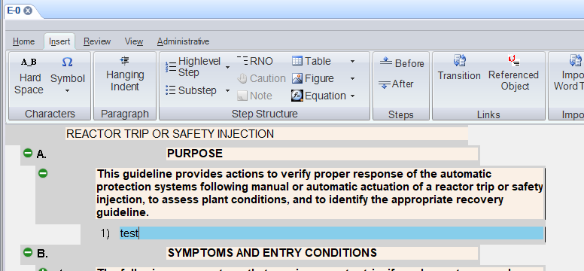

- In the Symptoms and Entry Conditions section change one of the high level steps to “High Level with Parenthesis Tab”
- Verify the step number had a )

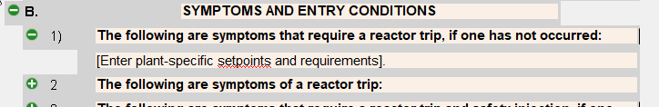

- Expand procedure step 2 and verify the sub-step is still a letter with a period

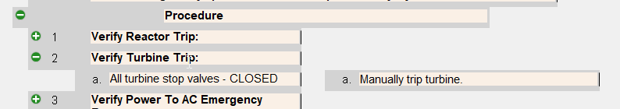

- Open the properties for the Procedure section and un-check the Print Section Number and Title
- Print the procedure.
- Verify Purpose and the Symptoms and Entry section numbers and titles print
- Verify the Procedure section title does not print
- Verify each Note on step 1 has a bullet

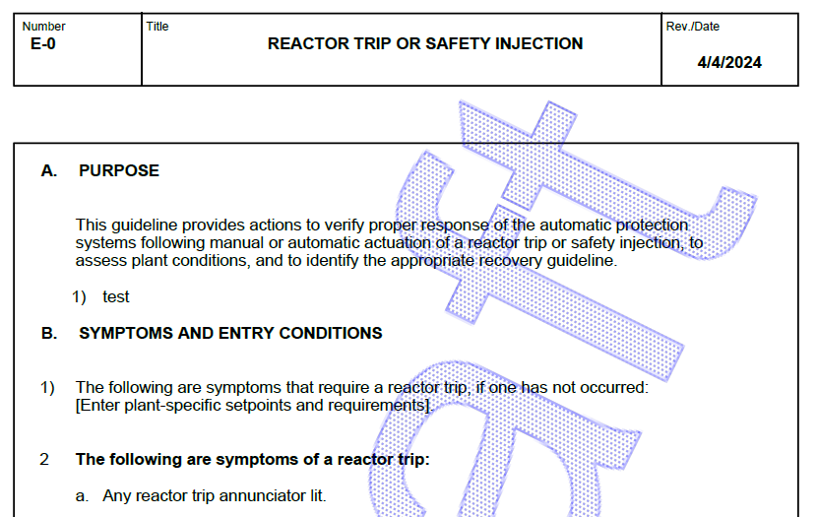

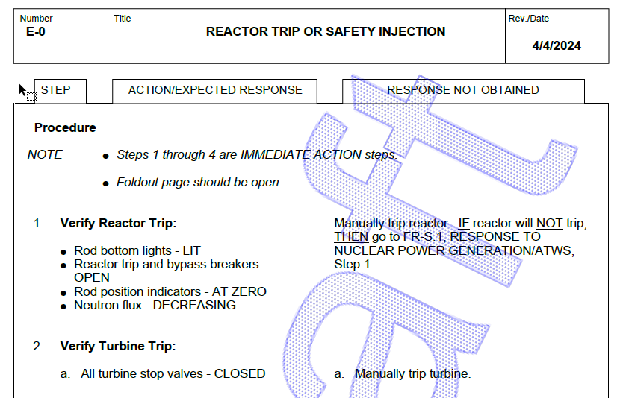

Changes/Additions to User Documentation:

N/A

