January 15, 2026

Applicability: GEN

Internal Release Information:

B2026-002 When parens are inside a parent / child, printing a double parens.

When "(tunable)" was added to the RO return value that has Parent/Child turned on in the field, that return value will print "(turnable))" - with two closing parentheses.

In Vogtle data, Customer turned on Parent/Child on the Setpoint field in the Alarms CSD grouping.
Added "(tunable)" to the Setpoint's default value in CDS-ARP-001-172

The value looks good in the editor but prints with two closing parens.

- [Check this box if a sql query or a data fix applies to this update].

Generic External Release:
Parent/Child default values containing parenthesis will now print the correct number of parenthesis.

Plant Specific Information for Release Letter:
N/A

Testing Requirements:
There are 4 test cases for this.
(Test case #1 is what changed / was corrected. Test cases #2-4 are to verify the fix did not break anything else.)
Test Case #1: Parent/child using default value with parens in RO
Example RO:
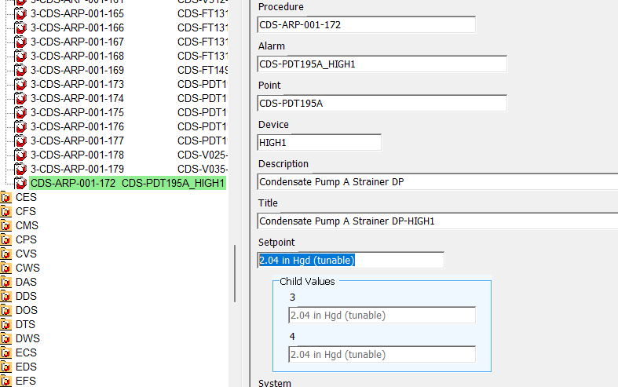
- Can use the db and ROs at
V:\Proms Versions\Test Version\Data to use for testing\B2026-002
- Open Procedure CDS-ARP-001-172
- Printing the procedure for a unit – the RO “2.04 in Hgd (tunable)” should print correctly with only 1 closing parens: (Note previously showed properly in the editor but printed 2 closing parens when printing.)
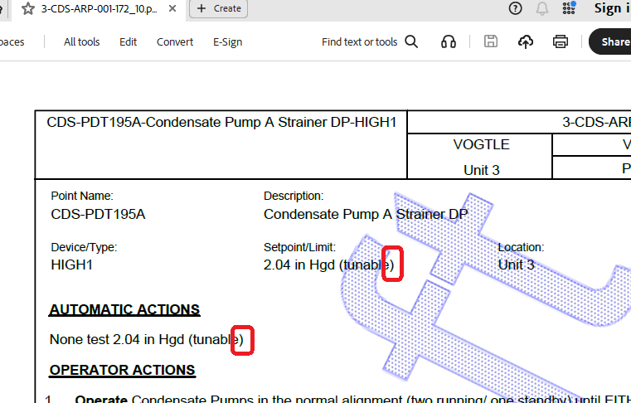

Test Case #2: Parent/child not using default value with parens in RO

Example RO:
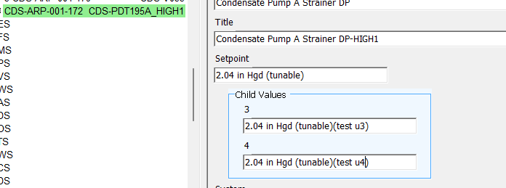
- Can either modify an RO at
V:\Proms Versions\Test Version\Data to use for testing\B2026-002
Or create a new RO
- Utilize the RO in a Parent/Child Procedure & print the procedure for a unit.
- Need to verify that RO text will still be properly pulled in. (This was previously ok, but need to verify that it still works properly after changes were made to correct for Test Case #1)

Test Case #3: Not Parent/child with parens in RO

- Need to create a RO without parent child that has a parens in the value or use a db / procedure that already has one & use it in a procedure.
- Printing the procedure, the ROs value should pull in properly. (This was previously ok, but need to verify that it still works properly after changes were made to correct for Test Case #1)

Test Case #4: Not Parent/child with no parens in RO

- Need to create a RO without parent child that does not have a parens in the value or use a db / procedure that already has one & use it in a procedure.
- Printing the procedure, the ROs value should pull in properly. (This was previously ok, but need to verify that it still works properly after changes were made to correct for Test Case #1)

Changes/Additions to PROMS Manual and Training Videos:
[Do not use this section – for MRV/DMJ use]
- CSM submitted for PROMS User Manual: ____________.
- CSM submitted for training videos: ____________.

