November 17, 2025 and updated November 19, 2025

Applicability: GEN

Internal Release Information:

C2019-036 View Only mode work with Checked Out Procedures

When a user is in "View Only" mode, they should be able to view checked out procedures (used to be B2019-142) Ask for by BNPP but is generic.

Added the ability for a user to open checked out procedures in view only mode as well as a method to refresh the view of a procedure in PROMS (without exiting and re-entering PROMS) and disabled the Step Properties tab while in “View Only Mode”.

- [Check this box if a sql query or a data fix applies to this update].

Generic External Release:
Added the ability for a user to open checked out procedures in view only mode as well as a method to refresh the view of a procedure in PROMS and disabled the Step Properties tab while in “View Only Mode”.

Plant Specific Information for Release Letter:
N/A

Testing Requirements:
- Use Any DB (will need to log in as 2 different users at the same time)
- TESTING TREEVIEW: Open a procedure with one user and then attempt to open the same procedure with the other user --- Should be prompted with a prompt similar to:

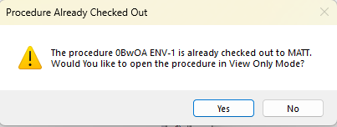
- No – should not open
- Yes – should open in view only mode. In View Only mode, verify the following:
- Text cannot be entered.
- View Only is highlighted in the View tab of the ribbon.
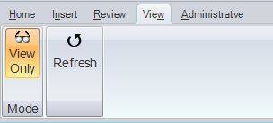

- TESTING WITH THE REMEMBER TAB: Follow the same steps as above, but each user should open the procedure using the Remember tab and opening the same procedure being remembered.

- TESTING FROM THE OPEN OPTION ON THE V BUTTON: Follow the same steps as above, but each user should open the procedure using the Open option located on the V button.
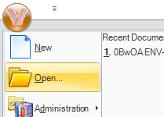

- TESTING FROM THE INCOMING TRANSITION OPTION: Follow the same steps as above, but each user should open the procedure by selecting the Incoming Transitions tab and attempting to open the same procedure from the results frame

- TESTING FROM THE SEARCH TAB UNDER TOOLS: Follow the same steps as above, but each user should open the same procedure by performing a global search and selecting the same procedure from the results frame.

- TESTING FROM THE SEPARATE WINDOWS FEATURE: Follow the same steps as above, but each user should open the same procedure having the procedure open in Separate Windows.

General Testing While in View Only Mode:

- Verify that the View Only mode cannot be toggled when another user is still in the same procedure:
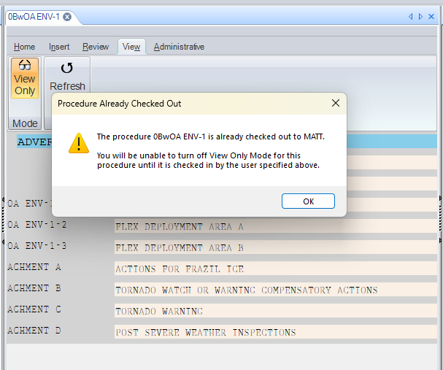
- If the other user checks in / closes the procedure or if the other user enables view only mode, then the first user should be able to leave view only mode.
- When clicking on a step, the Step Properties tab should be disabled (i.e. items/tabs should not be selectable).

- Exiting “View Only Mode” should re-enable the step properties.
- In addition to normal selecting/deselecting “View Only Mode” via the ribbon, this also needs tested when a procedure starts in “View Only Mode” because of Remember Tabs.
- The Properties page for a procedure should be disabled when a Procedure already checked out.
- Selecting Properties on a Section of a checked-out procedure should display the Procedure Already Checked Out message box:
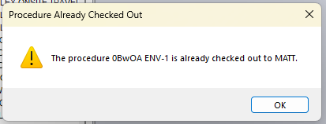
- Selecting Properties on a Working Draft Folder with a checked-out procedure should display the Working Draft Already Checked Out message box:
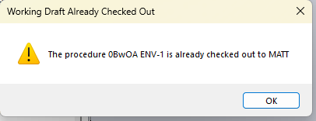
- The approval function should be disabled when a procedure is already checked-out.

- When multiple Users have a procedure open in “View Only Mode” for more than a minute, the procedures should not automatically close. This had been a feature that was changed whereby procedures that were open but not checked out would auto close after a certain number of seconds.

Testing the Refresh Button in View Only:

- Open the same procedure with multiple users. With the user who is able to make changes, make some changes.
- As a user in View Only mode, choose the Refresh button in the View ribbon. This should refresh their procedure with the added changes. It should not matter which steps / sub-steps are selected and their relation to where the changes are made in the procedure (i.e. if changes are made to the selected step, a step above it, or a step in the same procedure but a different section than the selected step or if changes are made to the procedure title).
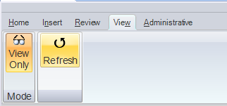
- For another of the user’s in View Only mode, have multiple tabs open (one being View Only and the other not), verify that the Step Properties panel should enable/disable properly when swapping between the tabs.
- For a user with View Only mode, click the Refresh button multiple times in a row (without waiting for it to refresh). Verify that PROMS does not become unresponsive. i.e. – it will eventually finish doing all the refreshes rather than getting stuck in a deadlock trying to do them all at once.

Changes/Additions to PROMS Manual and Training Videos:
[Do not use this section – for MRV/DMJ use]
- CSM submitted for PROMS User Manual: ____________.
- CSM submitted for training videos: ____________.

