November 20, 2025

Applicability: GEN

Internal Release Information:

B2025-063 Show User in View Mode

Once a user has gone into View Mode, their username disappears from the bottom of the edit window. Go into a database and into a procedure. Choose View Only from the View button in the Ribbon. Notice that the username is now gone and only says "View". De-select View so that you're back in Edit mode. The username does not come back.

- [Check this box if a sql query or a data fix applies to this update].

Generic External Release:
User name and role will now show at the bottom in PROMS regardless of whether or not user is in View Mode.

Plant Specific Information for Release Letter:
N/A

Testing Requirements:
- Use Any DB
- Open a procedure
- Toggle View Mode on via the Ribbon
- Name and role should remain in the ribbon at the bottom.
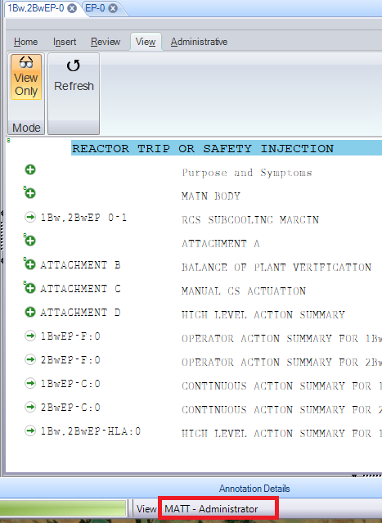

- Exit PROMS leaving the tab open.
- Enter PROMS as a different user and open that same procedure.
- Open PROMS for the original user so that Remember Tabs causes the Procedure to Open in View Only Mode.
- Name and role should show in the ribbon at the bottom.

Changes/Additions to PROMS Manual and Training Videos:
[Do not use this section – for MRV/DMJ use]
- CSM submitted for PROMS User Manual: ____________.
- CSM submitted for training videos: ____________.

