October 9, 2025

Applicability: GEN

Internal Release Information:

B2025-054 Wrong Page Numbers in CAS Summary

Found on Vogtle when Lydia was changing certain step types when a section containing CAS steps has “Print Section Number and Title”.

- [Check this box if a sql query or a data fix applies to this update].

Generic External Release:
N/A – Found Internally. Unlikely to occur for customer.

Plant Specific Information for Release Letter:
N/A – Found Internally. Unlikely to occur for customer.

Testing Requirements:
- Use Vogtle data at:
V:\Proms Versions\Test Version\Data to use for testing\B2025-054
- Open EOP-SDP-1
- Generate a CAS Summary
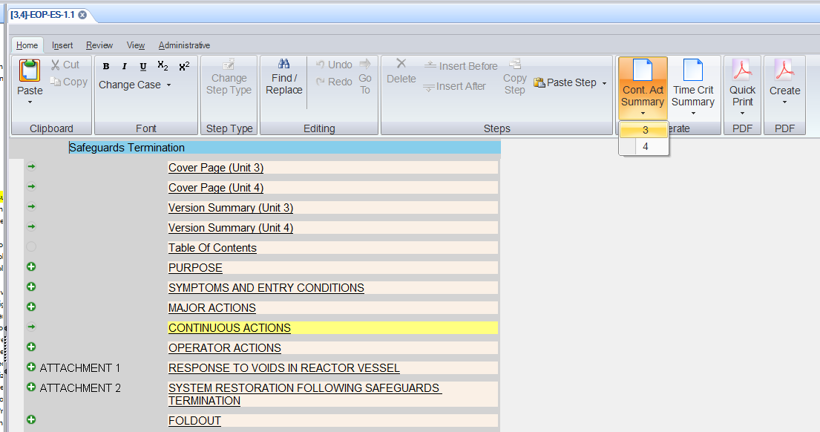

- Also Print that procedure
- Page Numbers in the CAS Summary should match printed page numbers

Changes/Additions to PROMS Manual and Training Videos:
[Do not use this section – for MRV/DMJ use]
- CSM submitted for PROMS User Manual: ____________.
- CSM submitted for training videos: ____________.

