September 16, 2024

Applicability: All Plants

Internal Release Information:
B2024-073
Correct Object Reference Error that can occur in debug mode when utilizing Edit item from the Debug toolbar at the bottom of the application.

Note - this bug is only in Debug Mode / Is not customer facing.

- [Check this box if a sql query or a data fix applies to this update].

Generic External Release:
N/A - This change is an internal housekeeping item that is not client facing.

Plant Specific Information for Release Letter:
N/A

Testing Requirements:
- Use any plants database
- Open PROMS in Debug Mode
- Select the First Procedure under the First Working Drafts folder.
- Then Select Edit Item in the Debug Toolbar.
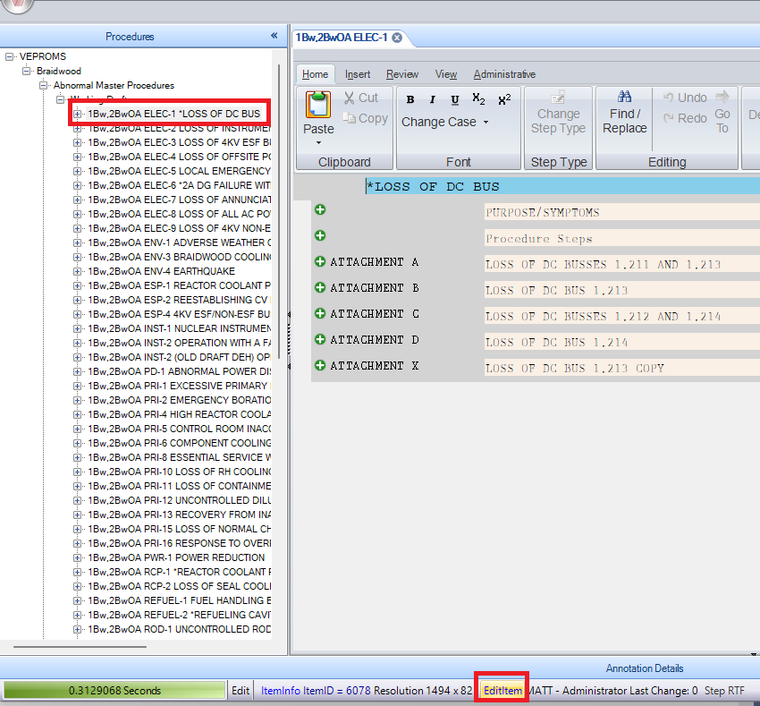

- The Active Parent Should be none
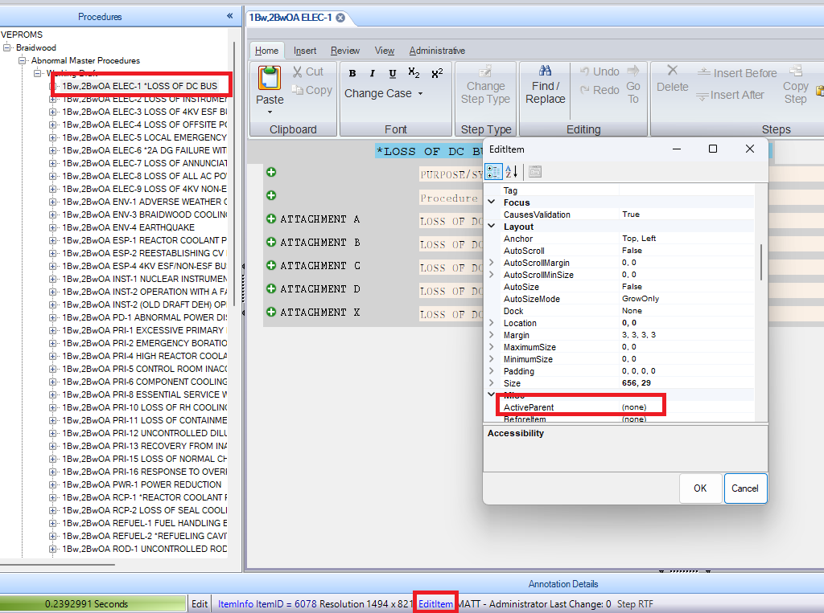
- You should not receive a Null Reference Exception / the ActiveParent should not be:

- 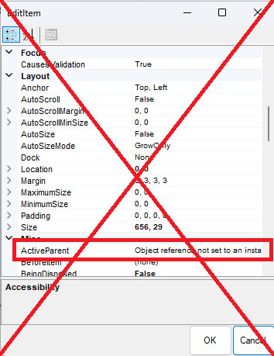

Changes/Additions to PROMS Manual and Training Videos:
[Do not use this section – for MRV/DMJ use]
- CSM submitted for PROMS User Manual: ____________.
- CSM submitted for training videos: ____________.

