3/27/2024

Applicability: B2024-018: Catawba – Enhanced document link issue with sub-sections in source but not in enhanced document

Internal Data Fixes: NA

Internal Release:

B2024-018: Catawba – Enhanced document link issue with sub-sections in source but not in enhanced document. When the source document has a sub-section and the enhanced background (or deviation) does not, the query that finds what is available to link to did not go up an additional level to find the link/id so no steps where listed as available to link to. The query, vesp_ListUnlinkedItems was modified (in promsfixes.sql) to allow this additional level/sub-section check.

Generic External Release: NA

Plant Specific Information for Release Letter:

Catawba: When determining step availability for linking to an enhanced background, if a procedure contains sub-sections, check the sub-sections parent section for determining what steps are available for linking if none are found within the sub-section.

Note that if the procedure has a section with a sub-section that should be linked to the Enhanced Background, Create Missing Enhanced Background Document Section should be done from the section not the sub-section. Proms will automatically update the text of the linked Enhanced Document from the source document and if the link is done at sub-section the section text in the Background document will be updated to ‘Operator Actions’, i.e. this may not be desired in this situation. In the following, the link should be created from the ‘Case I’ section, not the ‘C’ sub-section, otherwise the section text ‘Loss of ND Train Without Large Vent Path Established’ will be overwritten with ‘Operator Actions’ in the Background.

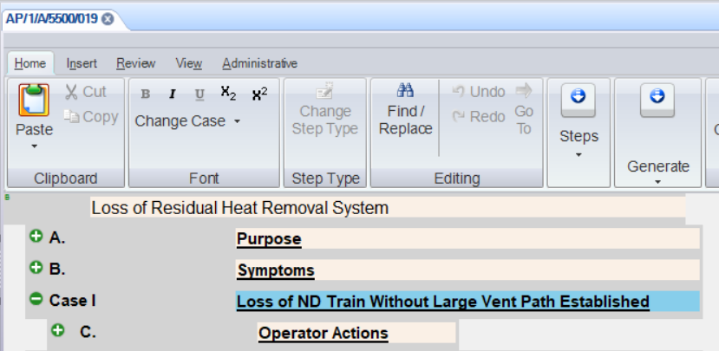

Testing Performed:

See Testing Required.

Testing Requirements:

Using the Catawba (CNS) sql database:

£ Update PromsFixes.sql
£ On Catawba Unit 1 AP’s/Working Draft, select Properties from the context menu. From the Enhanced tab, verify that there is an enhanced Background document listed and it connects to Unit Specific AP Background Document/Working Draft. If not create that link.
£ Open Catawba Unit 1 AP’s/Working Draft:AP/1/A/5500/019 in the editor. Using the right mouse button when positioned on the procedure title in the editor, select to Create Missing … Procedure’.
£ From the Create Missing.. dialog, select ‘’Link to Existing’ radio button, select the 019 procedure from the dropdown list and then select ‘OK’ to create the link.

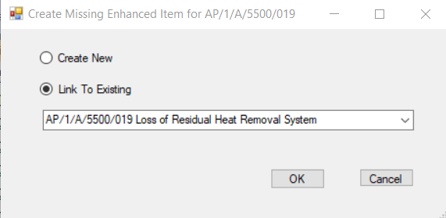

£ Position on the section ‘Case I’, and using the right mouse button, select to Create Missing…Section. From the dialog, select ‘Link to Existing’ radio button, select ‘Case I’ from the list and select ‘OK’ to create the link.

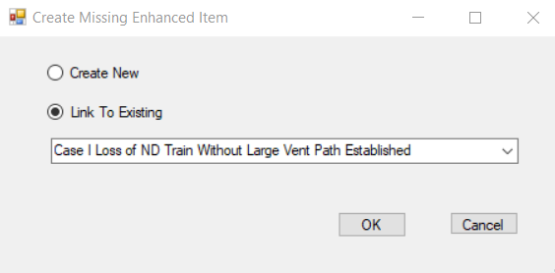

£ Position on the first high level step under ‘C’ Operator Actions. Using the right mouse button when positioned on the HLS select to Create Missing … Step’. From the dialog, VERIFY that the ‘Link to Existing’ radio button is enabled, select it. VERIFY that a list of steps exists, select the first step from the list and select ‘OK’ to create the link.

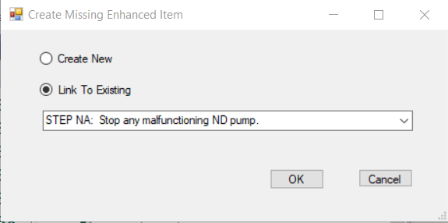

£ When positioned on this High Level Step, using the right mouse button select the Go To Background Document to verify that the background document is opened in the editor and the cursor is positioned on the first HLS in the background.

Changes/Additions to User Documentation: NA

