December 9, 2025

Applicability: Vogtle Units 3&4

Internal Release Information:
F2025-041
Added a non-bolded high level CAS step type for use in single column attachment

- [Check this box if a sql query or a data fix applies to this update].

Generic External Release:
N/A

Plant Specific Information for Release Letter:
N/A - format under development.

Testing Requirements:
Use Vogtle Units 3&4 data
- Update formats
- Edit Attachment 1, Section 4.0, step 19 and change the high level step to “Not Bolded Continuous Action Step”

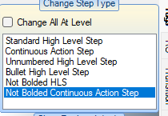

- Verify the Continuous Action Step is not bolded in the editor and when printed (you might need to restart PROMS due to caching keeping it in memory)

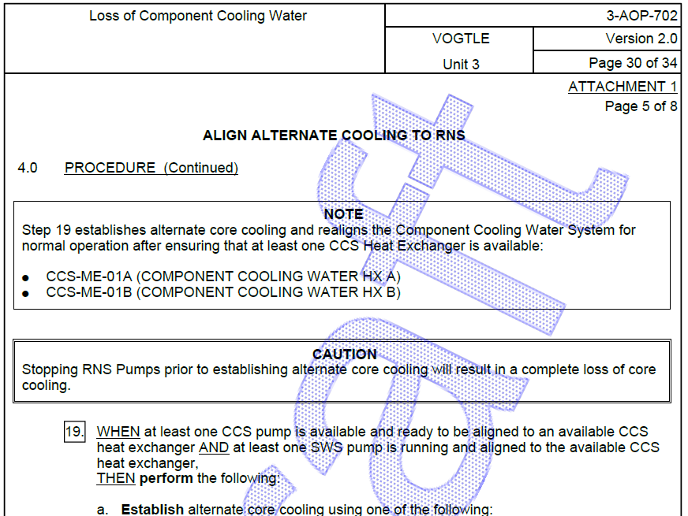

Changes/Additions to PROMS Manual and Training Videos:
[Do not use this section – for MRV/DMJ use]
- CSM submitted for PROMS User Manual: ____________.
- CSM submitted for training videos: ____________.

