May 5, 2025

Applicability: TUE

Internal Release Information:
B2025-026 - AND Substeps are Printing as Sequential Substeps in the ERG format /
B2025-027 - Bottom Continue message now appears due to the AND step type being now sequential and step compression being shut off

Examples:
ERG - Master; ERG - Working Draft - Production; EOP-0.0A,B Section C Step 1
ERG - Master; ERG - Working Draft - Production; EOP-0.0A,B Procedure Steps Step 27.a RNO

- [Check this box if a sql query or a data fix applies to this update].

Generic External Release:
N/A

Plant Specific Information for Release Letter:
Note: There were some pagination changes due to step compression being turned off.
In some cases (like Master; ERG - Working Draft - Production; EOP-0.0A,B Procedure Steps Step 27.a RNO), it might be helpful to change Equipment Lists with a Preceding Blank line to Equipment Lists to keep an entire step on one page.

Testing Requirements:
- Use Comanche Peak ERG Data
- - AND Substeps need to Print as Bulleted and not as Sequential Substeps in the ERG format
- Bottom Continue message should not appear when bulleted steps are separated (except when causes breaking of sequential substeps / RNOs)
- Examples:
ERG - Master; ERG - Working Draft - Production; EOP-0.0A,B Section C Step 1
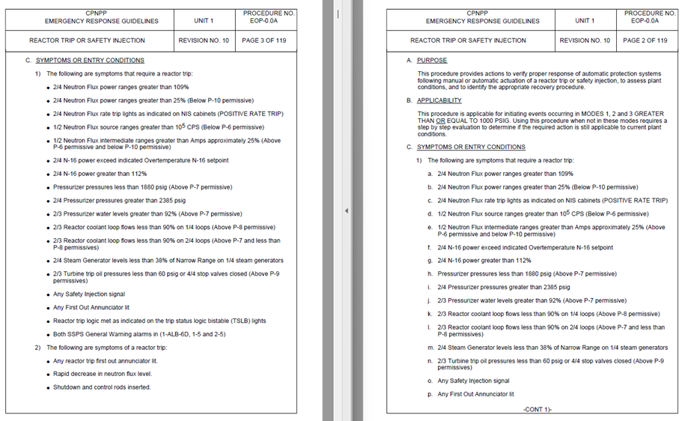
- Example: ERG - Master; ERG - Working Draft - Production; EOP-0.0A,B Procedure Steps Step 27.a RNO
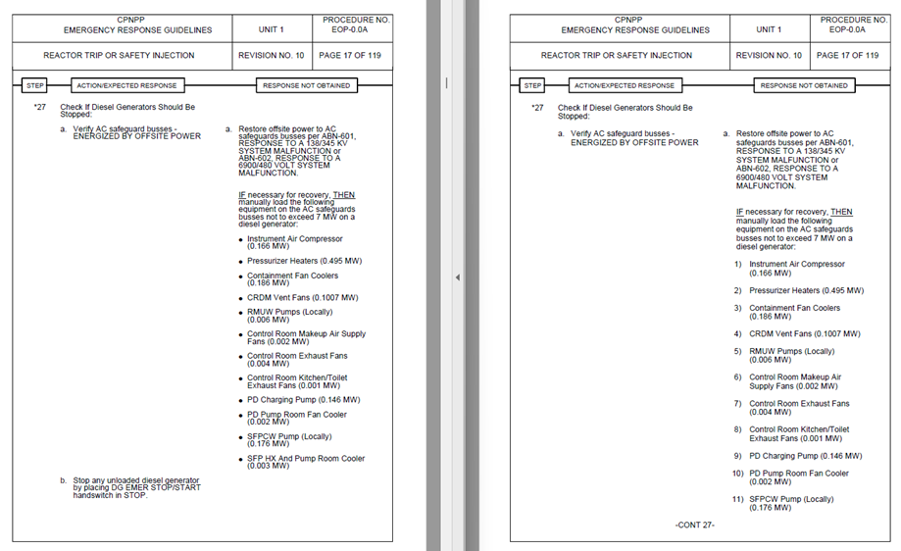

- Note: that in above case, may receive Continue Message if Step Moves to the next page (which may be a result of Step Compression being turned off – which as requested by Comanche Peak). There were some pagination changes due to step compression being turned off. In some cases (like Master; ERG - Working Draft - Production; EOP-0.0A,B Procedure Steps Step 27.a RNO), it might be helpful to change Equipment Lists with a Preceding Blank line to Equipment Lists to keep an entire step on one page.

- Testing should also be done in the ABNormal Section Types to verify the step numbering/bulleting is correct.

Changes/Additions to PROMS Manual and Training Videos:
[Do not use this section – for MRV/DMJ use]
- CSM submitted for PROMS User Manual: ____________.
- CSM submitted for training videos: ____________.

