7/17/2024

Applicability: All Plants with Multi return value ROs

Internal Release:

B2022-118

Search/Referenced Objects/multi-return value headers produce a sql exception. If the header (level above the multi-return values) is selected, a message box with ‘Search Error:SqlException – String or binary data would be truncated’ is displayed. Once this problem was fixed, no ROs would be found, this was also fixed.

- [Check this box if a sql query or a data fix applies to this update].

Generic External Release:

Search for Referenced Objects and selection of a multi-return value header was presenting an error message box stating that a Sql Exception occurred. This has been fixed.

Plant Specific Information for Release Letter: NA

Testing Requirements:

Using Braidwood sql database:
£ Expand in tree view Abnormal Master, Elect-3 and select to bring Procedure Steps up in editor.
£ Insert a few ROs from the Equipment/OPEN Offsite Power…/Breakers/ACB <u>413 group into different steps (HLS 1 & 2 in image below):

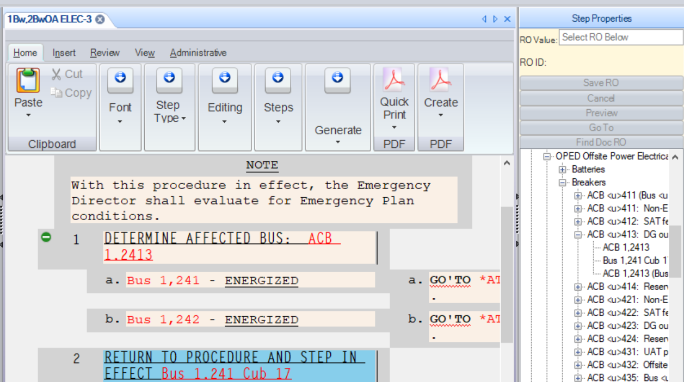

£ Open up the Tools/Search/Reference Objects tab
£ Select one of the ROs inserted and Search to verify that it is listed in results (this worked before fix – test for completeness).
£ Select the ACB <u>413> header and Search to verify that items are listed in results (this tests fix)
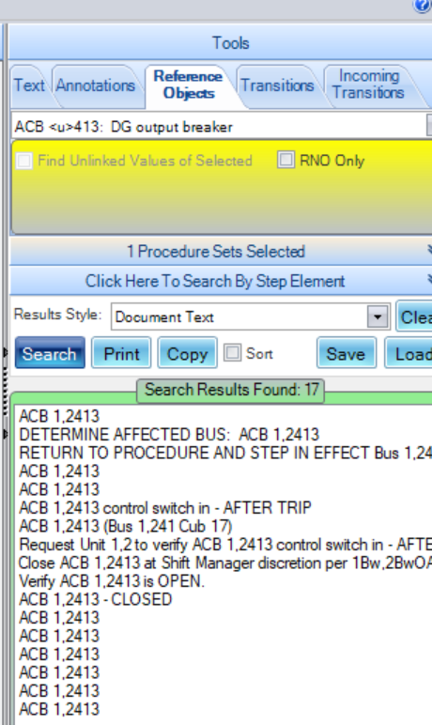

£ Select the Breakers header and Search to verify that items are listed in results (this tests fix), NOTE that this search takes a long time to complete

Changes/Additions to PROMS Manual and Training Videos: NA
- CSM submitted for PROMS User Manual: ____________.
- CSM submitted for training videos: ____________.

