September 25, 2025

Applicability: GEN

Internal Release Information:

C2015-028 Add Editorial Mode to PROMS Step Editor

- [Check this box if a sql query or a data fix applies to this update].

Generic External Release:
Added an Editorial Mode to the PROMS Step Editor ribbon and right mouse button menus when the cursor is on a section or step. While in editorial mode, changes made will not produce change bars. If a change bar previously existed, then it will remain. The functions of the Editorial Mode feature include:

  - Selecting the Editorial Mode will toggle “Editorial Mode” On/Off.
  - Toggling will change the mode for all currently open tabs and opening a new tab will open in the previous state.
  - While Editorial Mode is active:
  - The selected step will be highlighted in green.
    - If a step already contained a change-bar, it would continue to do so.
  - If a step did not contain a change bar and changes were made while in Editorial Mode, then a change bar will not be added.
  - The information above also includes any changes made by the spell checker while in Editorial Mode.
  - The currently selected step field shall have a light green background instead of sky blue.
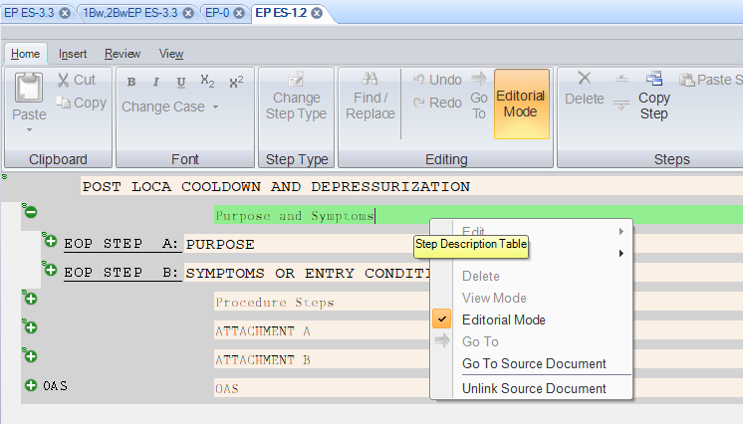
  - Change bars in linked background steps should now show based on the linked parent step. This should be the case despite the reason for the change bar not showing i.e. Editorial Mode vs SpellCheck vs Calvert Cliffs ChangeID format flag)

Plant Specific Information for Release Letter:
Calvert Cliffs –The Editorial Mode feature works in conjunction with the existing EC/Change ID feature. This allows a user to easily enter a number of changes to a procedure that would require a change id/change bar, but can exclude a particular change that should not be marked as a change, such as a misspelling or typo.
- While Editorial Mode is active, it will behave as if there is no Change ID or EC entered into the Change ID field.
- When Editorial Mode is deactivated, the entered Change ID will then be used.

Testing Requirements:
- Use Any DB (except Calvert Cliffs, D.C. Cook, Farley, or Vogtle).
- As an Administrator:
- Click on a step that does not have a change bar and select Editorial Mode from the ribbon. The step will be highlighted in green.
- Make a change to the step.
- Move off the step and verify no change bar has been added.
- While still in Editorial Mode, find a step with an existing change bar and make an edit to the step.
- Move off the step and verify the change bar is still on the step.
- Deselect Editorial Mode in the ribbon.
- Click on a step that does not have a change bar and select Editorial Mode from the right mouse button menu. The step will be highlighted in green.
- Make a change to the step.
- Move off the step and verify no change bar has been added.
- While still in Editorial Mode, find a step with an existing change bar and make an edit to the step.
- Move off the step and verify the change bar is still on the step.
- Right-click on each step section of the procedure (in the edit window) and verify the Editorial Mode option is listed.
- Close PROMS and open PROMS again, this time selecting to go in as a Reviewer.
- Verify that Editorial Mode is not available from the right mouse button menu.

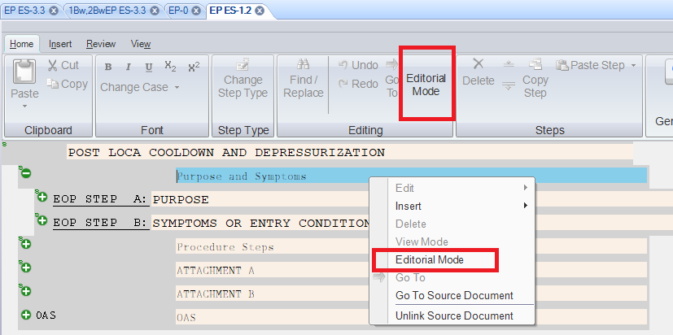

Background Procedure Testing:
- Open a Source procedure which has linked backgrounds or deviations.
- Right click on a step with no change bar and select Editorial Mode.
- Make a change to the step and verify no change bar has been added to the step.
- Go to the linked enhanced document (using the right mouse button menu).
- Verify the change is shown in the enhanced document and that you are in Editorial Mode.
- Make a change to a step in the enhanced document and verify no change bar has been added to the step.
- Print both the Source and the Enhanced procedure and verify there is no change bar on the edited steps.

Calvert Cliffs Testing:
- Open an EOP in the Calvert database and turn on Editorial Mode using either method.
- Enter a ChangeID when prompted.
- Make a change to a step without a change bar.
- Move off the step and verify no change bar has been added.
- Print the procedure and verify there is no change bar on the step.
- Turn off Editorial Mode and make a change to a step.
- Move off the step and verify a change bar is on the step along with the change ID.
- Print the procedure and verify there is a change bar with the change ID.
- Go to another procedure and do NOT enter a change ID.
- Turn on Editorial Mode and make a change to a step.
- Verify there is no Change ID on the Change ID tab in the ribbon and that there is no change bar.
- Turn off Editorial Mode, make a change to the step, and move off the step.
- Verify there is a change bar, but no change ID.
- Print the procedure and verify there is a change bar but no change ID on the step.

Farley Testing:
- As an administrator, open an EOP in the Farley database.
- Select Editorial Mode from the ribbon.
- Run Spell Check and make a change.
- Verify there is no change bar.
- Turn off Editorial Mode and run spell check again.
- Make a change and verify there is no change bar (this is the way Spell Check works for them).

Changes/Additions to PROMS Manual and Training Videos:
[Do not use this section – for MRV/DMJ use]
- CSM submitted for PROMS User Manual: ____________.
- CSM submitted for training videos: ____________.

