October 31, 2025

Applicability: GEN

Internal Release Information:

C2021-035 Add Refresh Tree Option at highest level

Consider a method to refresh the entire tree at the highest level. This would be beneficial for multi-user and other circumstances when PROMS doesn't update until you close and re-open PROMS (e.g. Updating formats).

- [Check this box if a sql query or a data fix applies to this update].

Generic External Release:
Added an option to refresh the PROMS tree at the highest level. This can be used in place of restarting PROMS when in multi-user to refresh items changed / added.

Plant Specific Information for Release Letter:
N/A

Testing Requirements:
- Use Any DB
- Log into PROMS twice (as different users)
- For one user add a folder
- For the other – Refresh the Tree by right clicking on the PROMS node and selecting “Refresh Tree”
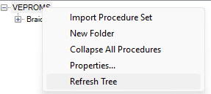
- The Added folder should now show in the tree.
- For one user, add (or copy) a procedure
- For the other – Refresh the Tree by right clicking on the PROMS node and selecting “Refresh Tree”
- The Added procedure should now show in the tree.
- For the next part – use DB for Braidwood
- Open a procedure that uses CWE (like Abnormal Procedures Unit 0 -> 0BwOA ELEC-1)
- When printing, you will notice at bottom of Page 2, Page 2 of …
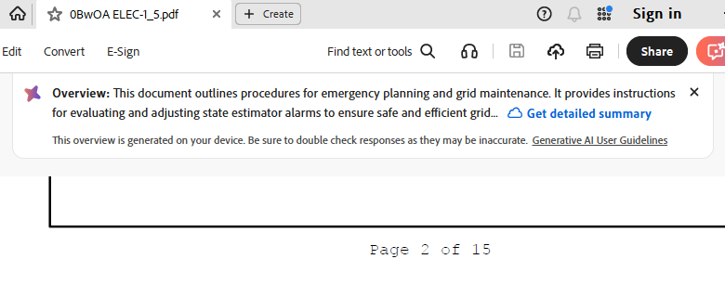

- Use the V button->Admin->Update formats
Update to the format located at:
V:\Proms Versions\Test Version\Data to use for testing\C2021-035
(After this, do not close PROMS until done testing as these steps should be done in conjunction to make sure that the cache is refreshed)
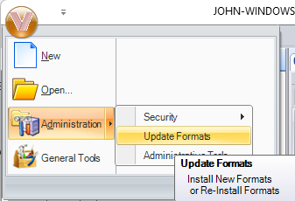

- After that, Refresh the Tree - Refresh the Tree by right clicking on the PROMS node and selecting “Refresh Tree”
- Printing after refreshing the tree should use the new format file.
You will be able to tell this as the word “test” will be added to the page footer for Procedure Steps
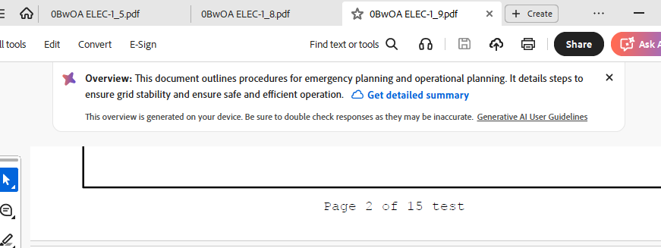

Changes/Additions to PROMS Manual and Training Videos:
[Do not use this section – for MRV/DMJ use]
- CSM submitted for PROMS User Manual: ____________.
- CSM submitted for training videos: ____________.

