February 5, 2024

Applicability: Vogtle Units 3 & 4

Internal Data Fixes:
After updating the formats in the Vogtle Units 3 & 4, run the Admin Tool to update/refresh the transitions.

Internal Release:
F2024-008
Updated transition definitions to title case section numbers, section titles, and procedure titles. Also surround section titles with parenthesis.

Generic External Release:
N/A

Plant Specific Information for Release Letter:
Vogtle Units 3 & 4
Transitions that include section numbers and titles will display the section number and section title in title case and will surround section titles in parenthesis.

Testing Requirements:
Use Vogtle Unit 3 & 4 data
- Update formats
- Run Admin tools, click on the Links tab, select the Refresh Transitions
- Expand the Local set under the ARPs and select the first procedure ASS-ARP-010 then click the Process Links

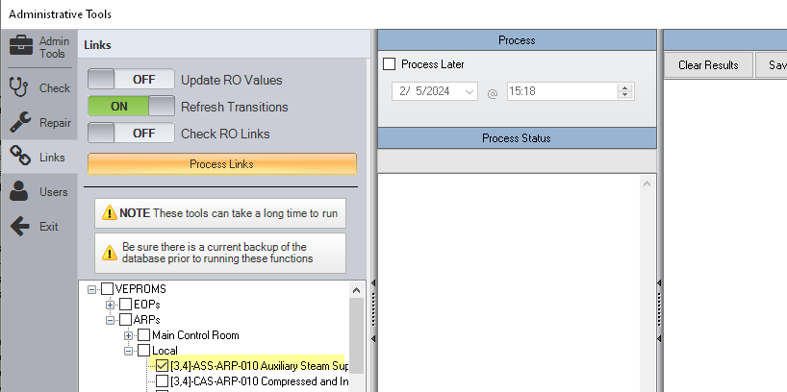
- Once done, close Amin Tools and open that procedure in the PROMS editor.
- Expand step 3 in the INSTRUCTIONS section
- Verify the section numbers are title cased and the section title is surrounded by parenthesis

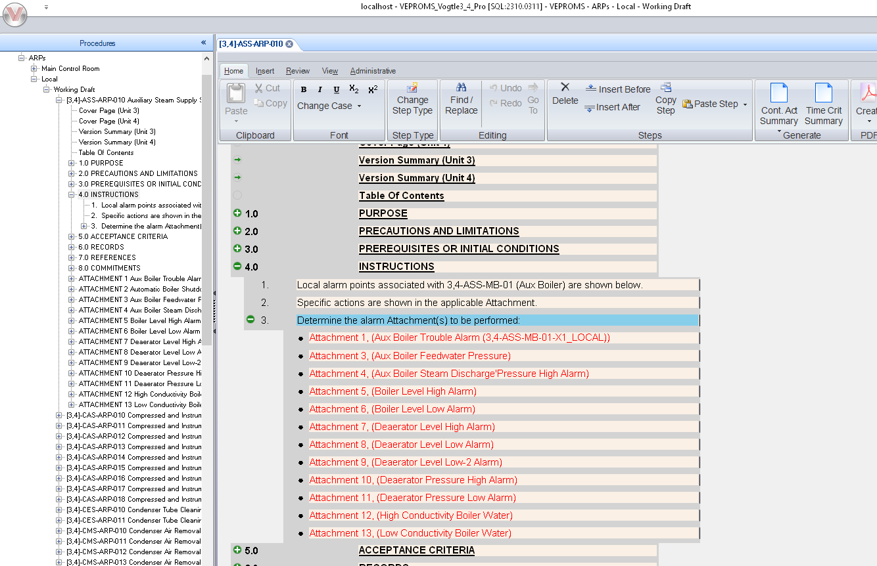

Changes/Additions to User Documentation:

N/A

